1. **Figures in the main text**

**Fig.1**

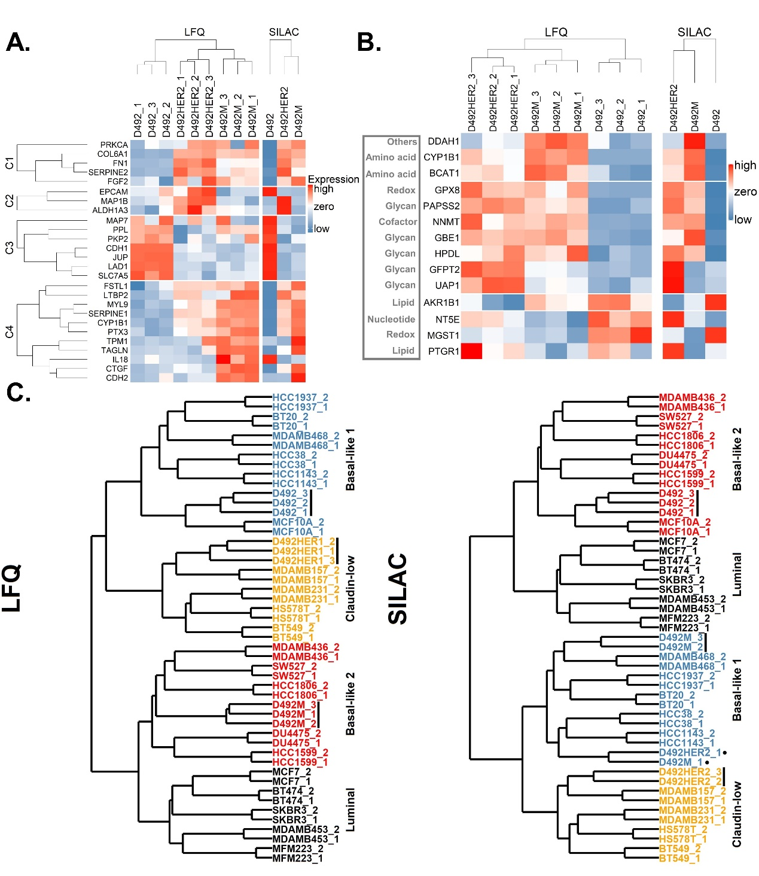

***Figure 1.* D492 EMT cell model. (A)** Dysregulation of EMT markers in D492 cell model were consistent with literature. As shown, there was a consistency between LFQ (left) and SILAC (right) with exceptions, EPCAM and IL18. The results from SILAC were in agree with the literature. ALDH1A3 showed downregulated in literature while no change in D492M and upregulated in D492HER2 in this study. The EMT markers were from the EMT-core gene list of 130 genes identified by meta-analysis of 18 independent and published gene expression studies (GES) of EMT which focused on different cell types and treatment modalities (Groger et al., 2012). **(B)** Dysregulation of EMT metabolic makers in D492 cell model compared to the literature. There was a consistency between LFQ (left) and SILAC (right) except for NT5E. SILAC was consistent with the literature. HPDL, AKR1B1 and MGST1 were in an opposite trend compared to the literature. The mesenchymal metabolic signature (MMS) in literature (Shaul et al., 2014) was referred in this analysis. For detailed description of each EMT marker mentioned in Fig. 1A and 1B, please refer to the Supplementary Data 4. **(C)** Classification of D492 cell model. Using iBAQ expression of proteins identified in both literature and in this study, D492, D492M and D492HER2 were clustered with other pre-classified breast cell lines (Lawrence et al., 2015). LFQ data (left) classified D492 as “Basal-like 1” (in blue), D492M as “Basal-like 2” (in red) and D492HER2 as “Mesenchymal-like/claudin-low” (in orange) while SILAC data (right) classified D492 as “Basal-like 2” (in red), D492M as “Basal-like 1” (in blue) and D492HER2 also as “Mesenchymal-like/claudin-low” (in orange). LFQ and SILAC raw data were quantified by iBAQ quantification method in MaxQuant.

***Fig.1A***

***Location****:*

*C:\Users\lenovo\OneDrive - Háskóli Íslands\PC-HI\5 ProteomicPaper\Figures&Tables in the paper\Figures\Figure1\1A\Meta-core gene list.R*

*C:\Users\lenovo\OneDrive - Háskóli Íslands\PC-HI\5 ProteomicPaper\Figures&Tables in the paper\Figures\Figure 1\1A*

***Note:*** *the genes in the heatmap also includes genes without significant pvalue less than 0.05. For each protein, the SILAC median values for one cell line were used for the plot.*

***Fig.1B***

***Location****:*

*"C:\Users\lenovo\OneDrive - Háskóli Íslands\PC-HI\1 DundeeProteomicDataSet_14112017\ProteomicDataAnalysisV3*

*C:\Users\lenovo\OneDrive - Háskóli Íslands\PC-HI\2 SILIC_DundeePhosphoproteomicsDataset\Results\Proteomics\Analysis Results - OR _QIONG_Organized*

*C:\Users\lenovo\OneDrive - Háskóli Íslands\PC-HI\5 ProteomicPaper\Figures&Tables in the paper\EMTMetaboliteMarker_heatmap*

*C:\Users\lenovo\OneDrive - Háskóli Íslands\PC-HI\5 ProteomicPaper\Figures&Tables in the paper\EMTMetaboliteMarker_heatmap\Rfiles"*

*C:\Users\lenovo\OneDrive - Háskóli Íslands\PC-HI\5 ProteomicPaper\Figures&Tables in the paper\EMTMetaboliteMarker_heatmap\Figures*

***Note:*** *the Heatmap plotting R file was copied from the MetabolicTargetHeatmap and mordifed based on that*

*the genes in the heatmap also includes genes without significant pvalue less than 0.05*

*1. Import LFQ data from "Proteomics_LFQ_summary_16.04.2018,xlsx"*

*2. Import SILAC data from "1 Proteomics_SILAC_summary_11.10.2018.xlsx"*

*3. import the metabolic markers from the paper "Markers.xlsx"*

*4. find the markers in both LFQ and SILAC*

*5. Log2 transform*

*6. z-score*

*7. Heatmap plotting*

*8. for details, refer to the Rfiles*

*9. For each protein, the SILAC mean values for one cell line were used for the plot.*

***Fig.1C***

***Location****:*

*C:\Users\lenovo\OneDrive - Háskóli Íslands\PC-HI\5 ProteomicPaper\Figures&Tables in the paper\Figures\Figure 1\1C*

*C:\Users\lenovo\OneDrive - Háskóli Íslands\PC-HI\1 DundeeProteomicDataSet_14112017\iBAQ_TNBC\7 2541 Proteins in iBAQ and literature and with all detected_z score.xlsx*

*C:\Users\lenovo\OneDrive - Háskóli Íslands\PC-HI\1 DundeeProteomicDataSet_14112017\iBAQ_TNBC\iBAQ_SILAC_2\SILAC_Literature_TNBC_5385.xlsx*

*C:\Users\lenovo\OneDrive - Háskóli Íslands\PC-HI\5 ProteomicPaper\Figures&Tables in the paper\Figures\Figure 1\1C\TNBC_clustering_dendrogram_withHER2&Tumors.R*

***Note:*** *How it was generated?*

*LFQ:*

*1, find proteins in both LFQ and Literature using Protein ID in Excel at first then R later;*

*2, log2(), replacing missing values and z-score in Perseus*

*3, merge two datasets in Persues*

*4, export from Persues, plot in R*

*(LFQ didn't filter anything and just replace the missing values directly, cause the normal distribution was ok)*

*C:\Users\lenovo\OneDrive - Háskóli Íslands\PC-HI\1 DundeeProteomicDataSet_14112017\iBAQ_TNBC\PerseusTextFile\PerseusOutputTable_2541 proteins in both iBAQ and literature_z score.txt -> 7 2541 Proteins in iBAQ and literature and with all detected_z score.xlsx*

*SILAC:*

*1, Use GeneName to match SILAC and Literature (SILAC has GeneName and ProteinName, but no ProteinID)*

*2, find proteins in both SILAC and Literature using GeneName in Excel*

*3, log2() in Perseus*

*4, filter valid values, for Literature, 70% total valid values and for SILAC, 2/3 as valid*

*5, replacing missing values and z-score in Perseus*

*6, merge two datasets in Perseus*

*7, export from Perseus, plot in R"*

*C:\Users\lenovo\OneDrive - Háskóli Íslands\PC-HI\1 DundeeProteomicDataSet_14112017\iBAQ_TNBC\iBAQ_SILAC_2\PerseusIntputTable_SILAC_Literature_TNBC.xlsx (you can find all the proteins with ENSG in the raw file) -> Literature.txt & SILAC.txt -> PerseusOutputTable_SILAC_Literature_TNBC.sps -> PerseusOutputTable_SILAC_Literature_TNBC_5533.txt -> SILAC_Literature_TNBC_5385.xlsx (delete all the NAs)*

**Fig.2**

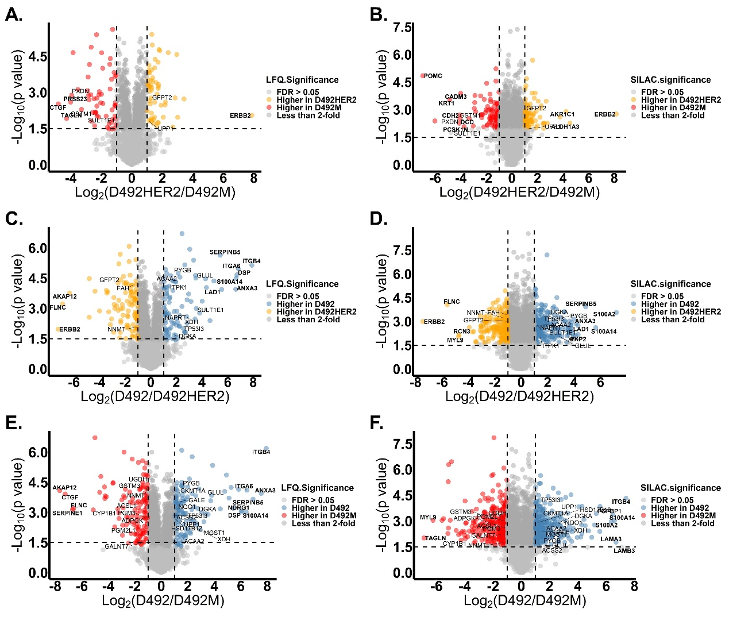

***Figure 2.*** **Statistical analysis of LFQ and SILAC expression of proteome in two different cell types: D492HER2 vs. D492M (A-B), D492 vs. D492HER2 (C-D), D492 vs. D492M (E-F).** Proteins with FDR less than 0.05 and fold change more than 2 were colored. Metabolic enzymes differently expressed in two cell types and consistent between LFQ and SILAC were labeled in the plots and proteins with significant differences and big fold changes (at least 6-fold difference between D492 and D492M, 4-fold between D492HER2 and D492 and 4-fold between D492HER2 and D492M) were marked in bold. Horizontal dash line indicated p value at 0.05 and vertical dash lines indicated fold change at 2-fold. Proteins with biggest differences between D492M and D492HER2 were PRSS23, CTGF, TAGLN, POMC, CADM3, KRT1, CDH2, CDC, PCSK1N, AKR1C1, ALDH1A3 and ERBB2 involving in cell adhesion and metabolism. Proteins differently expressed in D492HER2 and D492 were AKAP12, FLNC, ERBB, RCN3, MYL9, SERPINB5, ITGB4, ITGA6, DSP, S100A14, LAD1, ANXA3 and PKP which were mainly involved in cell adhesion, structure, cell-cell interaction and signaling. Lastly, a group of proteins which were similar to the differences observed with the other cell types were differently expressed between D492 and D492M, including AKAP12, CTGF, FLNC, SERPINE1, MYL9, TAGLN, ITGB4, ITGA6, ANXA3, SERPINB5, NDRG1, DSP, S100A14, FGFBP1, S100A2, LAMA3, LAMB3.

***Location****:*

*C:\Users\lenovo\OneDrive - Háskóli Íslands\PC-HI\5 ProteomicPaper\Figures&Tables in the paper\MatchingLFQ&SILAC\PerseusOutputTable_SILAC_EM.txt (HE, HM)"*

*"C:\Users\CSB\OneDrive - Háskóli Íslands\PC-HI\5 ProteomicPaper\Figures&Tables in the paper\VolcanoPlots*

***Note:***

*LFQ:*

*1. in Perseus ""VolcanoPlots.sps"", output tables: PerseusOutPutTable_X vs. Y*

*2. in R: ""VolcanoPlotForLFQ_X.R"", input the output tables from Perseus (around 2,700 proteins)*

*3. plot in R*

*SILAC:*

*1. Input output table from Perseus (in folder: .\MatchingLFQ&SILAC)*

*2. in R: ""VolcanoPlotForSILAC_X.R"", input the output tables from Perseus (around 5,100 proteins)*

*3. plot in R*

*4. SILAC: Median*

*Double check the labels on the volcano plot by comparing them to the “supplementary data 6 – significant proteins”, lots of genes are not in the dataset:*

1. *It doesn’t have to be match, cause the “supplementary data 6” was reporting mean of LFQ and SILAC, the proteins have to be detected in both and in the same direction also being significant in both.*
2. *LAMB3 in SILAC-EM, it has a p value a bit over 0.05, so not in the supplementary data*
3. *PKP2 in SILAC-HE, not significant in LFQ (check on the raw data in “C:\Users\lenovo\OneDrive - Háskóli Íslands\PC-HI\5 ProteomicPaper\Figures&Tables in the paper\MatchingLFQ&SILAC\5&6”)*
4. *PRSS23 in LFQ-HM, not valid in SILAC*
5. *POMC in SILAC-HM, not detected in LFQ*
6. *KRT1 in SILAC-HM, not detected in LFQ*
7. *DCD in SILAC-HM, not detected in LFQ*
8. *PCSK1N in SILAC-HM, not detected in LFQ*
9. *AKR1C1 in SILAC-HM, not detected in LFQ*
10. *ALDH1A3 in SILAC-HM, not significant in LFQ*

**Fig.3**



***Figure 3.*** **GO annotation of differently expressed proteome between two cell types.** **(A-B)** Annotation of the differences in biological processes (BP) **(A)** and cellular components (CC) **(B)** between D492HER2 and D492M. **(C-D)** Annotation of the differences in BP **(C)** and CC **(D)** between D492HER2 and D492. **(E-F)** Annotation of the differences in BP **(E)** and CC **(F)** between D492M and D492. The whole proteome from SILAC dataset was used as background. Enriched GO annotation with enrichment factor more than 2 for BPs and more than 2/1.25/1.5 for CCs were plotted in a descending order (Fisher exact test, Benjamin-Hochberg FDR < 0.02). (Supplementary Data 6 were used for the GO annotation: Student T-test, Permutation-based FDR < 0.05 for LFQ; One sample T-test, p value of SILAC ratios < 0.05)

***Location:***

*C:\Users\lenovo\OneDrive - Háskóli Íslands\PC-HI\5 ProteomicPaper\Figures&Tables in the paper\Annotations\Perseus\EM&HE&HM_06.02.2019_LFQ&SILAC_significant*

*C:\Users\lenovo\OneDrive - Háskóli Íslands\PC-HI\5 ProteomicPaper\Figures&Tables in the paper\Annotations\Perseus\EM&HE&HM_06.02.2019_LFQ&SILAC_significant\Perseus_1.6.12.0*

***Note:***

*Data used for GO annotation in Perseus v1.6.12.0:*

*C:/Users/lenovo/OneDrive - Háskóli Íslands/PC-HI/5 ProteomicPaper/Figures&Tables in the paper/IPA/ImportFile – or “SupplementaryData6_DifferentlyExpressedProteins.xlsx"*

*1. load significant differently expressed genes in Perseus (only LFQ FDR < 0.05, no limit for SILAC p value)*

*2. use the whole proteome detected in SILAC as background*

*3. GO annotation*

*4. Fisher exact test, Benjamin-Hochberg FDR < 0.02*

*5. enrichment factor > 2 or 1.5 or 1.25 – just for easy-to-read*

*How the plot was generated:*

*EM&HE&HM_SILAC&LFQ_DataInput_07.02.2019.R 🡪 output: PerseusInPutTable_SILAC_EM&HE&HM_07.02.2019.txt 🡪 EM&HE&HM_SILAC&LFQ_07.04.2019.sps in here (C:\Users\lenovo\OneDrive - Háskóli Íslands\PC-HI\5 ProteomicPaper\Figures&Tables in the paper\Annotations\Perseus\EM&HE&HM_06.02.2019_LFQ&SILAC_significant\Perseus_1.6.12.0) 🡪 PerseusOutPutTable_X_Y_07.04.2019.txt 🡪 EM&HE&HM_SILAC&LFQ_Plotting_07.02.2019.R for plotting*

**Fig.4**

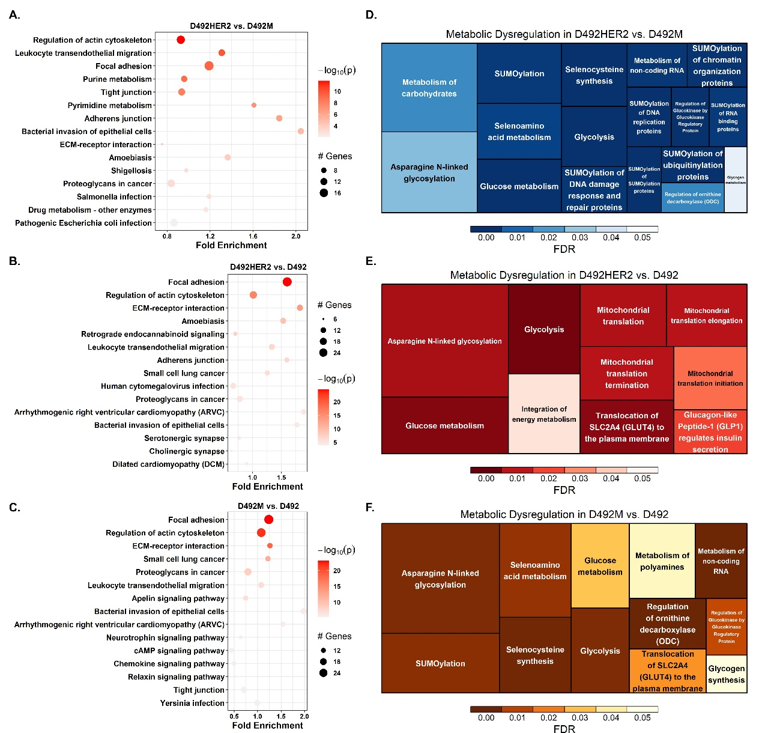

***Figure 4.* Dysregulated pathways between two cell types.** **(A)** KEGG pathways which involved in cell structure, migration, adhesion, nucleotide metabolism, invasion and proteoglycans in cancer etc. were differently enriched in D492HER2 vs. D492M. **(B)** Similar to D492HER2 vs. D492M, KEGG pathways differently enriched in D492HER2 vs. D492 were cell structure, migration, adhesion, invasion and proteoglycans in cancer. **(C)** KEGG pathways differently enriched in D492M vs. D492. Proteins involved in each KEGG pathway were in Supplementary Data 7. **(D)** Reactome metabolic pathways differently enriched in D492HER2 vs. D492M. **(E)** Reactome metabolic pathways differently enriched in D492HER2 vs. D492. **(F)** Reactome metabolic pathways differently enriched in D492M vs. D492. Proteins involved in each Reactome metabolic pathway were plotted in Supplementary Figure 5. (Data used for analysis: Supplementary Data 6; Student T-test, Permutation-based FDR < 0.05, one sample T-test, p value of SILAC ratio < 0.05,).

***Location:***

*C:\Users\lenovo\OneDrive - Háskóli Íslands\PC-HI\5 ProteomicPaper\Figures&Tables in the paper\Annotations\pathfindR\BubbleChart_2020.04.07*

*"C:\Users\CSB\OneDrive - Háskóli Íslands\PC-HI\5 ProteomicPaper\Figures&Tables in the paper\Annotations\Reactome\Metabolic Proteins_E vs M*

*C:\Users\CSB\OneDrive - Háskóli Íslands\PC-HI\5 ProteomicPaper\Figures&Tables in the paper\Annotations\Reactome\Metabolic Proteins_H vs E*

*C:\Users\lenovo\OneDrive - Háskóli Íslands\PC-HI\5 ProteomicPaper\Figures&Tables in the paper\Annotations\Reactome\Metabolic Proteins_H vs M"*

***Note:***

*Used the R code from:*

*C:\Users\lenovo\OneDrive - Háskóli Íslands\PC-HI\5 ProteomicPaper\Figures&Tables in the paper\Annotations\pathfindR\Rfiles\GOannotation_&enrichment_EM&HE&HM_2020.01.08.R*

***Bubble charts***

*1. take genes from 'SupplementaryData6_DifferentlyExpressedProteins'*

*2. in R, run ""pathfindR"" package, using ""Biogrid"" and ""KEGG""*

*3. 100 cycles*

*4. for the bubble chart, pvalues were mean of LFQ_FDR and SILAC_Pvalue*

*5. For the pathway heatmap, protein quantification data only used LFQ data (didn't use the heatmap)*

***Treemap plots:***

*1. take genes from 'SupplementaryData6_DifferentlyExpressedProteins'*

*2. put genes for D492 vs. D492M and D492 vs. D492HER2 separately into Reactome (up- and down-regulated genes are together)*

*3. Used default setting*

*4. download results*

*5. work in excel (FDR < 0.05)*

*6. manually pick up the metabolic pathways*

*7. deleted the 'metabolism of protein' and 'metabolism of RNA' the big groups (take big space in treemap and give less information)*

*8. used Supplementary Data 6 but didnt delete proteins with SILAC p value > 0.05 (which = C:\Users\lenovo\OneDrive - Háskóli Íslands\PC-HI\5 ProteomicPaper\Figures&Tables in the paper\IPA\ImportFile\Proteomics_LFQ&SILAC_X.xlsx files)*

**Fig.5**

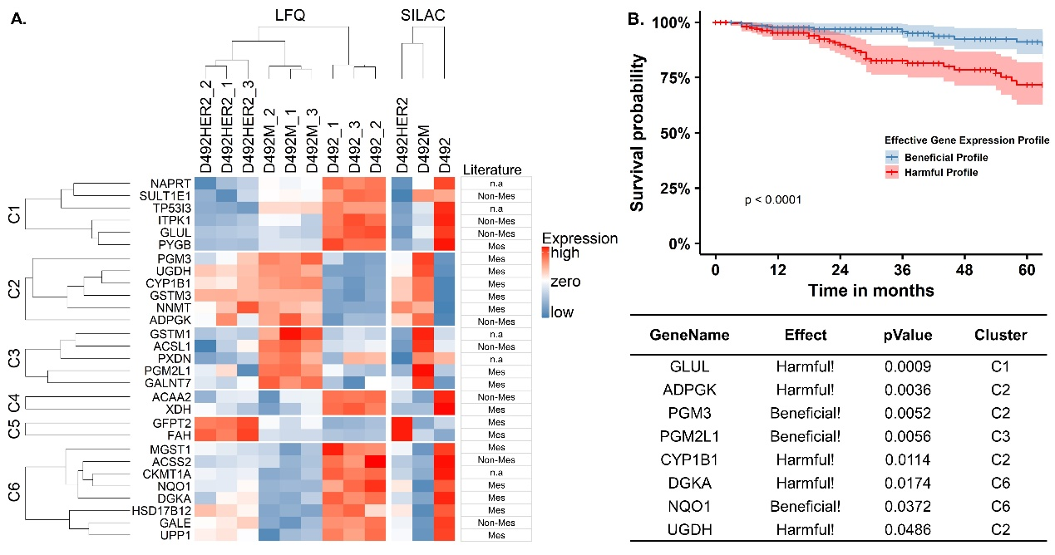

***Figure 5.*** **Metabolic targets identified by comparing one cell type to another. (A)** Differentially expressed metabolic proteins in D492HER2 vs. D492M, D492HER2 vs. D492 and D492M vs. D492 (student T-test, permutation-based FDR < 0.05 for LFQ, one sample T-test, p value of SILAC < 0.05, more than 2-fold in both LFQ and SILAC) were manually identified. Samples were in triplicates for both D492, D492M and D492HER2 in LFQ and SILAC experiments. For SILAC, median relative expression of each target for D492, D492M and D492HER2 was plotted. Targets were clustered into 6 clusters. The relative expression from the lowest to the highest for each metabolic protein was indicated in color scaled from blue to red, as shown in the color bar. We also listed on the right side the identified metabolic targets in mesenchymal (Mes) and non-mesenchymal (Non-Mes) groups based on literature (Shaul et al., 2014). n.a: not available in literature. **(B)** Survival analysis of the identified metabolic targets in breast cancer patients of all types revealed a group of enzymes might affect the outcome of patients’ survival. The enzymes exerted either beneficial or harmful effects on patients were listed in the table together with the p value for each enzyme’s effect on patients. Clusters in which the enzymes were resided were listed too. TCGA data, Breast Invasive Carcinoma (TCGA, Provisional), was used in this analysis.

***Location:***

*C:\Users\lenovo\OneDrive - Háskóli Íslands\PC-HI\5 ProteomicPaper\Figures&Tables in the paper\MetabolicTargetsHeatmap – Fig.5A*

*C:\Users\lenovo\OneDrive - Háskóli Íslands\PC-HI\5 ProteomicPaper\Figures&Tables in the paper\DPYD*

*C:\Users\lenovo\OneDrive - Háskóli Íslands\PC-HI\5 ProteomicPaper\Figures&Tables in the paper\SurvivalCurveGeneration_17.09.2019 – Fig.5B*

*C:\Users\lenovo\OneDrive - Háskóli Íslands\PC-HI\5 ProteomicPaper\Figures&Tables in the paper\SurvivalCurveGeneration_17.09.2019\Rfiles\SurvivalSignatureTest – Rfiles*

***Note****:*

*for the “profile” table, check on the file:*

*C:\Users\lenovo\OneDrive - Háskóli Íslands\PC-HI\5 ProteomicPaper\Figures&Tables in the paper\SurvivalCurveGeneration_17.09.2019\Outputs\ Effict-Organized-For-Plotting.xlsx or Effect_ALL_Sign_Final_all_29Genes.xlsx*

1. *all subtypes of breast patients*
2. *all 29 genes for analysis*
3. *20% of top or bottom patients for plotting*

**Fig.6**

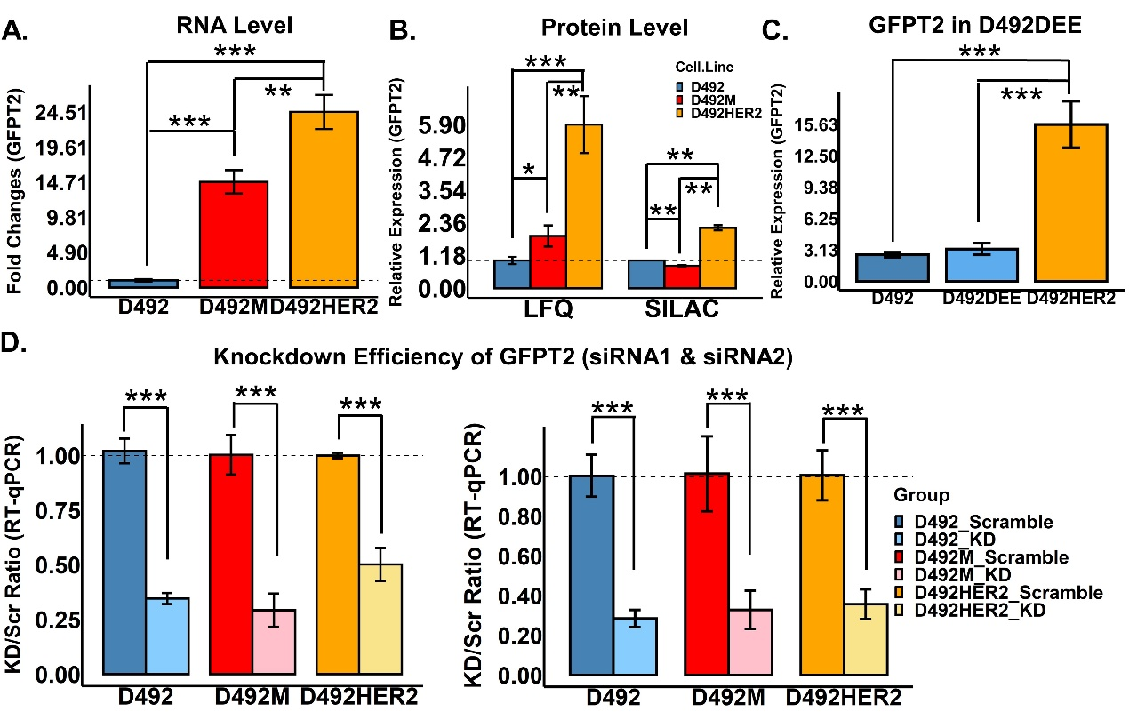

***Figure 6.* GFPT2 expression in D492, D492M and D492HER2.** **(A)** GFPT2 in three cell types showed highest expression of GFPT2 in D492HER2 while lowest expression at RNA level; **(B)** The protein expression of GFPT2 in the three cell types suggested highest expression of GFPT2 in D492HER2 followed by D492M and it was confirmed by both LFQ (left) and SILAC (right); **(C)** GFPT2 level in D492DEE which was the negative control cell line of D492HER2 indicated the increased expression of GFPT2 was not due to the artifacts from cell handling; **(D)** Knockdown efficiency of GFPT2 in three cell types with two different siRNAs showed that both siRNAs had relatively 50% - 80% knockdown. **\***: p < 0.05; **\*\***: p < 0.01; **\*\*\***: p < 0.001.

***Data used:***

*"C:\Users\lenovo\OneDrive - Háskóli Íslands\PC-HI\4 Experiments documents_QIONG\15 KEAP1\RT_qPCR data analysis.xlsx - this is for GALE, PGM2L1 and UGDH*

*C:\Users\lenovo\OneDrive - Háskóli Íslands\PC-HI\4 Experiments documents_QIONG\14 Knockdowns Experiments\Results\14 SQRDL\WideType\RTqPCR_WT_EMH_SQRDL_04.02.2020.xlsx - SQRDL, GFPT2 (didn't use this data for GFPT2)*

*C:\Users\lenovo\OneDrive - Háskóli Íslands\PC-HI\4 Experiments documents_QIONG\14 Knockdowns Experiments\Results\4 GFPT2 primers\RT_qPCR data analysis_GFPT2_EMH_10.06.2019.xlsx - For GFPT2*

*C:\Users\lenovo\OneDrive - Háskóli Íslands\PC-HI\5 ProteomicPaper\Figures&Tables in the paper\Figures\SupplementaryFig6\ProteomicPaperTargets_RNAexpression.xlsx - Template file for plotting*

*for DEE, check on the R file: C:\Users\lenovo\OneDrive - Háskóli Íslands\PC-HI\5 ProteomicPaper\Figures&Tables in the paper\Figures\SupplementaryFig7\Rfiles\DEE_HER2_LFQ.R*

*For KD efficiency: C:\Users\lenovo\OneDrive - Háskóli Íslands\PC-HI\4 Experiments documents_QIONG\14 Knockdowns Experiments\Results\7 RT_qPCR repeat_09.07.2019\RT_qPCR data analysis_repeat_09.07.2019 _D492changed (Changed the ""D492 KD efficiency data"" to the D492 data collected during the CDH1&CDH2 Experiment (Because the KD data detected for KD efficiency for D492 was not ideal)) - C:\Users\lenovo\OneDrive - Háskóli Íslands\PC-HI\4 Experiments documents_QIONG\14 Knockdowns Experiments\Results\8 KD_CDH1&2\D492\2019.10.28\RTqPCR_Result_D492_final.xlsx (since there were 4 replicates, took the mean of two of the replicates to get 3 replicates, so no need to change the R code had for 3 replicates)*

*siRNA2: C:\Users\lenovo\OneDrive - Háskóli Íslands\PC-HI\4 Experiments documents_QIONG\14 Knockdowns Experiments\Results\15 KDefficiency_siRNA1&2\RNA_GeneExpression.xlsx (this was a organized file, for the original data, go to C:\Users\lenovo\OneDrive - Háskóli Íslands\PC-HI\4 Experiments documents_QIONG\14 Knockdowns Experiments\Results\14 SQRDL\Knockdown\RTqPCR_KD_X_SQRDL_YYY.xlsx)"*

***location:***

*"function ""bar.plot.Rdata"" for protein levels*

*C:\Users\lenovo\OneDrive - Háskóli Íslands\PC-HI\5 ProteomicPaper\Figures&Tables in the paper\Glycan precursor analysis\Figures\Proteomic expression of target genes*

*C:\Users\lenovo\OneDrive - Háskóli Íslands\PC-HI\5 ProteomicPaper\Figures&Tables in the paper\Figures\SupplementaryFig6\Rfiles\GNexpression_LFQ_SILAC_04.09.2019.R & GNexpression_RNA_RTqPCR_04.09.2019.R*

*C:\Users\lenovo\OneDrive - Háskóli Íslands\PC-HI\5 ProteomicPaper\Figures&Tables in the paper\Figures\SupplementaryFig7*

*C:\Users\lenovo\OneDrive - Háskóli Íslands\PC-HI\5 ProteomicPaper\Figures&Tables in the paper\Glycan precursor analysis\KDexperimentRepeat_16.07.2019\QIONG\Rfiles\KDefficiency_RTqPCR_NoUGDH.R*

*C:\Users\lenovo\OneDrive - Háskóli Íslands\PC-HI\4 Experiments documents_QIONG\14 Knockdowns Experiments\Results\15 KDefficiency_siRNA1&2\Rfiles\KDefficiency_BarPlot.R"*

*"C:\Users\lenovo\OneDrive - Háskóli Íslands\PC-HI\5 ProteomicPaper\Figures&Tables in the paper\Figures\SupplementaryFig6*

*C:\Users\lenovo\OneDrive - Háskóli Íslands\PC-HI\5 ProteomicPaper\Figures&Tables in the paper\Figures\SupplementaryFig7\Figures*

*C:\Users\lenovo\OneDrive - Háskóli Íslands\PC-HI\5 ProteomicPaper\Figures&Tables in the paper\Glycan precursor analysis\KDexperimentRepeat_16.07.2019\QIONG\Figures - siRNA1*

*C:\Users\lenovo\OneDrive - Háskóli Íslands\PC-HI\4 Experiments documents_QIONG\14 Knockdowns Experiments\Results\15 KDefficiency_siRNA1&2\Figures - siRNA2"*

***Note:***

*function "bar.plot.Rdata" for protein levels*

**Fig.7**

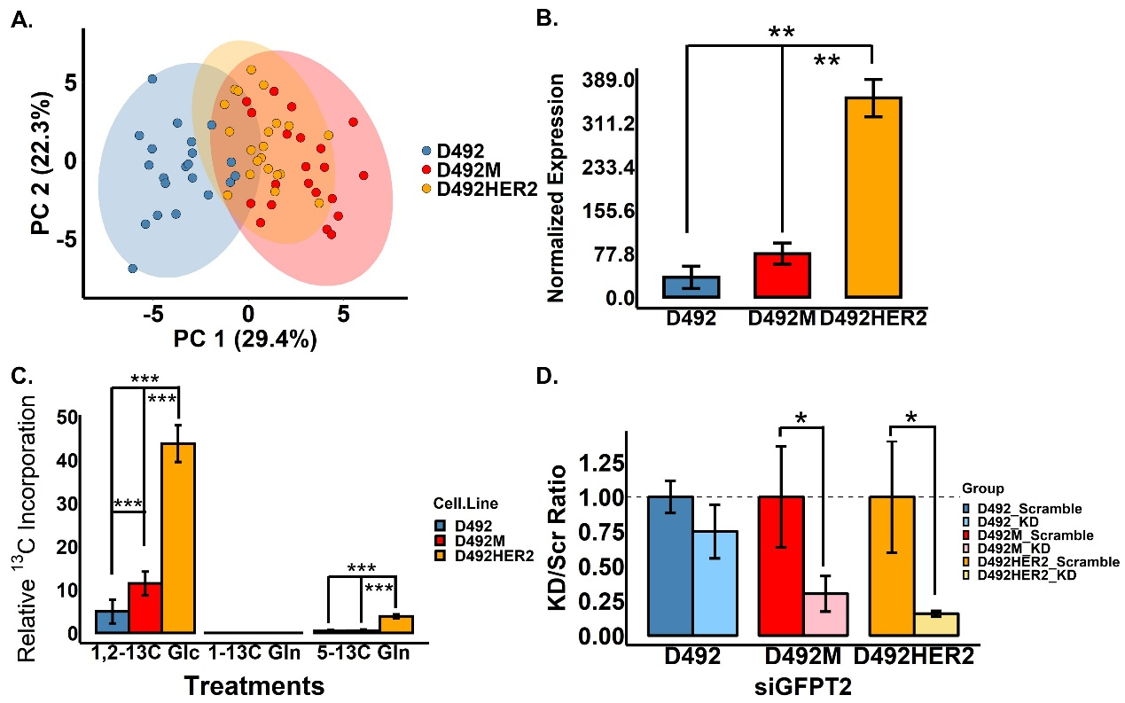

***Figure 7.*****Metabolome in three cell types***.* **(A)** Metabolome of D492 cells were different from D492M and D492HER2 while the metabolome in D492M and D492HER2 were similar. **(B)** UDP-GlcNAc was expressed higher in D492HER2 comparing to the other cell types. **(C)** Carbons incorporation into UDP-GlcNAc after 6 hours’ culture. Carbons from 1,2-13C Glc were highly incorporated into UDP-GlcNAc comparing to 5-13C Gln and 1-13C Gln in all three cell types. No carbon incorporation from 1-Gln in all three cell types. Higher rate of carbon incorporation into UDP-GlcNAc from both 1,2-13C Glc and 5-13C Gln was observed in D492HER2 comparing to D492 and D492M. Higher rate of carbon incorporation into UDP-GlcNAc from 1,2-13C Glc was observed in D492M comparing to D492. **(D)** Knockdown of GFPT2 decreased production of UDP-GlcNAc in both D492M and D492HER2. **\***: p < 0.05; **\*\***: p < 0.01; **\*\*\***: p < 0.001.

***Data used:***

*"PCA: C:\Users\lenovo\OneDrive - Háskóli Íslands\PC-HI\5 ProteomicPaper\Figures&Tables in the paper\Glycan precursor analysis\Combined_Acidic_Basic\KD_Metabolomics_Acidic_Basic_2020.04.18.xlsx (it is an already-organized datasets)*

*The raw data used for PCA:*

*Acidic: C:\Users\lenovo\OneDrive - Háskóli Íslands\PC-HI\5 ProteomicPaper\Figures&Tables in the paper\Glycan precursor analysis\KDexperimentRepeat_16.07.2019\QIONG\AcidicNeg_Knockdown_Metabolomics_3Scr_18.07.2019.xlsx & TargetedMetabolites-IS Database_17.07.2019.xlsx*

*Basic: C:\Users\lenovo\OneDrive - Háskóli Íslands\PC-HI\5 ProteomicPaper\Figures&Tables in the paper\Glycan precursor analysis\KDexperimentBasic_03.12.2019\BasicNeg_Knockdown_Metabolomics_NOV2019.xlsx & TargetedMetabolites-IS Database_Basic_NOV2019.xlsx*

*WT: C:\Users\lenovo\OneDrive - Háskóli Íslands\PC-HI\5 ProteomicPaper\Figures&Tables in the paper\Glycan precursor analysis\KDexperimentBasic_03.12.2019\Metabolomics_KD_EMH_Basic_03.12.2019\RawData.xlsx*

*13C: C:\Users\lenovo\OneDrive - Háskóli Íslands\PC-HI\5 ProteomicPaper\Figures&Tables in the paper\Metabolomics_Arnar_Labelling_April2019\ARNAR_Targeted_UDP_NaGlu_isotopologues_All_Cell_Lines.xlsx (for mean enrichment normalization, used Basic data: C:\Users\lenovo\OneDrive - Háskóli Íslands\PC-HI\5 ProteomicPaper\Figures&Tables in the paper\Glycan precursor analysis\KDexperimentBasic_03.12.2019\Metabolomics_KD_EMH_Basic_03.12.2019\RawData.xlsx)*

*KD: C:\Users\lenovo\OneDrive - Háskóli Íslands\PC-HI\5 ProteomicPaper\Figures&Tables in the paper\Glycan precursor analysis\KDexperimentRepeat_16.07.2019\QIONG\AcidicNeg_Knockdown_Metabolomics_3Scr_18.07.2019.xlsx*

*Protein amount for normalization: C:\Users\lenovo\OneDrive - Háskóli Íslands\PC-HI\4 Experiments documents_QIONG\14 Knockdowns Experiments\Results\5 ProteinConcentrationBCA_repeat_07.07.2019\BCA assay_repeat_08.07.2019.xlsx*

*"*

***Note:***

*"read ""0 Protocol-Basic.txt"" in C:\Users\lenovo\OneDrive - Háskóli Íslands\PC-HI\5 ProteomicPaper\Figures&Tables in the paper\Glycan precursor analysis\KDexperimentBasic_03.12.2019*

*read ""0 Protocol-Acidic.txt"" in C:\Users\lenovo\OneDrive - Háskóli Íslands\PC-HI\5 ProteomicPaper\Figures&Tables in the paper\Glycan precursor analysis\KDexperimentRepeat_16.07.2019\QIONG"*

***Location:***

*"PCA; C:\Users\lenovo\OneDrive - Háskóli Íslands\PC-HI\5 ProteomicPaper\Figures&Tables in the paper\Glycan precursor analysis\Combined_Acidic_Basic*

*WT&KD: C:\Users\lenovo\OneDrive - Háskóli Íslands\PC-HI\5 ProteomicPaper\Figures&Tables in the paper\Glycan precursor analysis\KDexperimentRepeat_16.07.2019\QIONG*

*13C: C:\Users\lenovo\OneDrive - Háskóli Íslands\PC-HI\5 ProteomicPaper\Figures&Tables in the paper\Metabolomics_Arnar_Labelling_April2019\Rfiles\Labelling_Arnar_EMH_TP_Normalized_27.01.2020.R & C:\Users\lenovo\OneDrive - Háskóli Íslands\PC-HI\5 ProteomicPaper\Figures&Tables in the paper\Glycan precursor analysis\KDexperimentBasic_03.12.2019"*

*"PCA: C:\Users\lenovo\OneDrive - Háskóli Íslands\PC-HI\5 ProteomicPaper\Figures&Tables in the paper\Glycan precursor analysis\Combined_Acidic_Basic*

*WT&KD: C:\Users\lenovo\OneDrive - Háskóli Íslands\PC-HI\5 ProteomicPaper\Figures&Tables in the paper\Glycan precursor analysis\KDexperimentRepeat_16.07.2019\QIONG\Figures*

*13C: C:\Users\lenovo\OneDrive - Háskóli Íslands\PC-HI\5 ProteomicPaper\Figures&Tables in the paper\Metabolomics_Arnar_Labelling_April2019\Figures"*

***Note:***

*README in C:\Users\lenovo\OneDrive - Háskóli Íslands\PC-HI\5 ProteomicPaper\Figures&Tables in the paper\ProteomicsManuscript_03.07.2019\NewFigures&Data_2020\1-MainFigures\Fig.7*

**Fig.8**

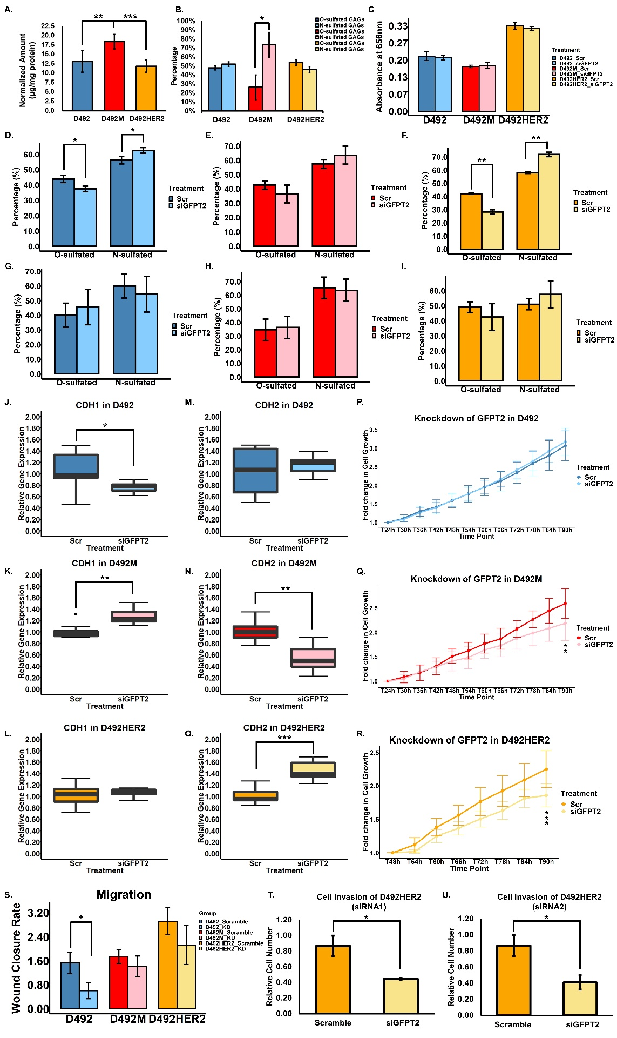

***Figure 8.* Functions of GFPT2. (A)** Total GAGs in ECM of D492, D492M and D492HER2. D492M cells had higher contents of GAGs in ECM. **(B)** Composition of N-sulfated GAGs and O-sulfated GAGs in ECM.Higher level of N-sulfated GAGs comparing to O-sulfated GAGs in ECM of D492M. **(C)** GFPT2 knockdown didn’t affect the total amount of GAGs in ECM of cells. **(D-F)** Knockdown of GFPT2 with siRNA1 increased N-sulfated GAGs in ECM of D492 **(D)** and D492HER2 **(F)**. **(G-I)** Knockdown of GFPT2 with siRNA2 did not affect the ratios of N-sulfated and O-sulfated GAGs in ECM of D492 **(G)**, D492M **(H)** and D492HER2 **(I)** though similar trend was observed in D492HER2. **(J-L)** Knockdown of GFPT2 decreased CDH1 in D492 **(J)** while increased CDH1 in D492M **(K)**. **(M-O)** Knockdown of GFPT2 decreased CDH2 in D492M **(N)** while increased CDH2 in D492HER2 **(O)**. (P-R) Knockdown of GFPT2 decreased growth of D492M **(Q)** and D492HER2 **(R)** after 90 hours from cell seeding. **(S)** D492 cell migration was slowed by knocking down of GFPT2. A decreasing trend was seen with D492M and D492HER2 without significance. **(T-U)** D492HER2 cell invasion was decreased after knockdown of GFPT2 and confirmed by both siRNA1 **(T)** and siRNA2 **(U)**. **\***: p < 0.05; **\*\***: p < 0.01; **\*\*\***: p < 0.001.

***Data used:***

*"WT-Total and N-O-*

*C:\Users\lenovo\OneDrive - Háskóli Íslands\PC-HI\4 Experiments documents_QIONG\13 Blyscan assay\4 Results_Blyscan_EMH_28.07.2019_final.xlsx*

*KD-Total*

*C:\Users\lenovo\OneDrive - Háskóli Íslands\PC-HI\4 Experiments documents_QIONG\14 Knockdowns Experiments\Results\10 KD_Blyscan\TotalGAGs_KD\TotalGAGs_KD_NoUGDH_EMH_03.02.2020.xlsx*

*KD-N-O-*

*C:\Users\lenovo\OneDrive - Háskóli Íslands\PC-HI\4 Experiments documents_QIONG\14 Knockdowns Experiments\Results\10 KD_Blyscan\DataAnalysisSummary_EMH_12.11.2019.xlsx (both siRNA1 & siRNA2) & DataAnalysisSummary_EMH_plotting.xlsx"*

*"C:\Users\lenovo\OneDrive - Háskóli Íslands\PC-HI\4 Experiments documents_QIONG\14 Knockdowns Experiments\Results\15 KDefficiency_siRNA1&2\RNA_GeneExpression.xlsx - EMT markers - all data used the experiment from SQRDL-siRNA1, except for D492M-CDH2 which used the data from CDH1&CDH2 experiment (C:\Users\lenovo\OneDrive - Háskóli Íslands\PC-HI\4 Experiments documents_QIONG\14 Knockdowns Experiments\Results\14 SQRDL\Knockdown\excel files & C:\Users\lenovo\OneDrive - Háskóli Íslands\PC-HI\4 Experiments documents_QIONG\14 Knockdowns Experiments\Results\8 KD_CDH1&2\KD_CDH1&2_Plotting\GNexpression_KD_AllExperiments_WithoutDelete_11.01.2020.xlsx)*

*C:\Users\lenovo\OneDrive - Háskóli Íslands\PC-HI\4 Experiments documents_QIONG\14 Knockdowns Experiments\Results\9 KD_GrowthCurve\KD_GrowthCurve_EMH_Plotting.xlsx & KD_GrowthCurve_EMH_Summary.xlsx &KD_GrowthCurve_EMH_Plotting_2020.04.14.xlsx (which was used in the end, same data with the last file but deleted two time points for E and M and changed the time points for x axis) - proliferation - E&M for 24h; H for 48h and High density*

*C:\Users\lenovo\OneDrive - Háskóli Íslands\PC-HI\4 Experiments documents_QIONG\14 Knockdowns Experiments\Results\12 Migration\GlycanKD_Migration_IncuCyto_ValidImages_2020.01.01.xlsx (E-Sheet 2, M-Sheet 9, H-Sheet 6) - Migration*

*C:\Users\lenovo\OneDrive - Háskóli Íslands\PC-HI\4 Experiments documents_QIONG\14 Knockdowns Experiments\Results\13 Invasion\MacroOutput\Summary_EMH_Bg&KD_2020.03.17.xlsx - invasion"*

***Location:***

*"C:\Users\lenovo\OneDrive - Háskóli Íslands\PC-HI\4 Experiments documents_QIONG\13 Blyscan assay\4 Results_Blyscan_EMH_28.07.2019_final.xlsx - WT - Total & N-O-*

*C:\Users\lenovo\OneDrive - Háskóli Íslands\PC-HI\4 Experiments documents_QIONG\14 Knockdowns Experiments\Results\10 KD_Blyscan - KD - N-O-*

*C:\Users\lenovo\OneDrive - Háskóli Íslands\PC-HI\4 Experiments documents_QIONG\14 Knockdowns Experiments\Results\10 KD_Blyscan\TotalGAGs_KD - KD - Total"*

*"C:\Users\lenovo\OneDrive - Háskóli Íslands\PC-HI\4 Experiments documents_QIONG\14 Knockdowns Experiments\Results\12 Migration\Rfiles\PlottingBarChartGene.R & PlottingMigrationRate_X_YYYY.R - Migration-BarChart*

*C:\Users\lenovo\OneDrive - Háskóli Íslands\PC-HI\4 Experiments documents_QIONG\14 Knockdowns Experiments\Results\13 Invasion\MacroOutput*

*C:\Users\lenovo\OneDrive - Háskóli Íslands\PC-HI\4 Experiments documents_QIONG\14 Knockdowns Experiments\Results\9 KD_GrowthCurve\Rfiles\KD_GrowthCurve_EMH_24+48+12_StartsFrom24h.R & KD_GrowthCurve_HER2highDensity_StartsFrom48h.R*

*C:\Users\lenovo\OneDrive - Háskóli Íslands\PC-HI\4 Experiments documents_QIONG\14 Knockdowns Experiments\Results\15 KDefficiency_siRNA1&2\Rfiles\BoxPlot_Function_OneGene_2020.02.24.R"*

*"C:\Users\lenovo\OneDrive - Háskóli Íslands\PC-HI\4 Experiments documents_QIONG\14 Knockdowns Experiments\Results\12 Migration\Figures - Migration*

*C:\Users\lenovo\OneDrive - Háskóli Íslands\PC-HI\4 Experiments documents_QIONG\14 Knockdowns Experiments\Results\13 Invasion\Figures - Invasion*

*C:\Users\lenovo\OneDrive - Háskóli Íslands\PC-HI\4 Experiments documents_QIONG\14 Knockdowns Experiments\Results\9 KD_GrowthCurve\Figures - Proliferation (24h for D492 and D492M; 48h for D492HER2)*

*C:\Users\lenovo\OneDrive - Háskóli Íslands\PC-HI\4 Experiments documents_QIONG\14 Knockdowns Experiments\Results\15 KDefficiency_siRNA1&2\Figures\CDH1&CDH2 - EMT markers"*

***Note:***

*"Check on the file: 4 Results_Blyscan_EMH_28.07.2019_final.xlsx*

*and*

*C:\Users\lenovo\OneDrive - Háskóli Íslands\PC-HI\4 Experiments documents_QIONG\14 Knockdowns Experiments\Results\10 KD_Blyscan\Rfiles*

*C:\Users\lenovo\OneDrive - Háskóli Íslands\PC-HI\4 Experiments documents_QIONG\14 Knockdowns Experiments\Results\10 KD_Blyscan\TotalGAGs_KD\Rfiles*

*"*

*"Excel for A-C*

*R for the rest"*

*"Growth Curve (Proliferation): microscope --> pictures --> Macro API & ImageJ --> R*

*Invasion: Evos --> pictures --> ImageJ & Macro API --> R*

*Migration: output from IncuCyte*

*EMT markers: RT-qPCR"*

*Except for Invasion, which was generated in Excel, the rest are generated in R*

*"Migration:*

*Generate two types of Plotting: Closure Rate*

*Wound confluence*

*The SD for D492M (Wound confluence curve) was from IncuCyte (because the data looked better)*

*Plot based on different cell types or Plot based on different genes for the bar plot*

*EMT markers:*

*1. used the results from the SQRDL_siRNA1 experiment*

*2. for D492M_CDH2, used the data from before ()C:\Users\lenovo\OneDrive - Háskóli Íslands\PC-HI\4 Experiments documents_QIONG\14 Knockdowns Experiments\Results\8 KD_CDH1&2\KD_CDH1&2_Plotting"*

**Fig.9**

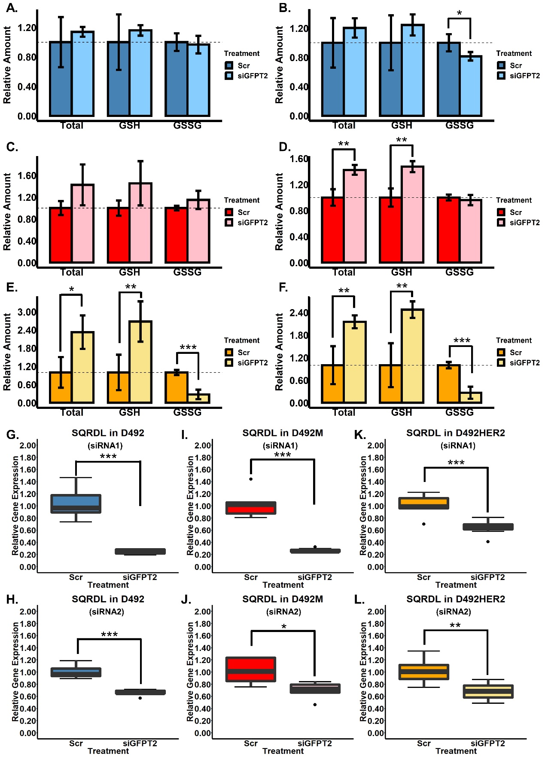

***Figure 9.* GFPT2 expression affects glutathione level in cells. (A-B)** Knockdown of GFPT2 with siRNA2 **(B)** decreased GSSG level in D492, however, there was no significant change with siRNA1 **(A)**. **(C-D)** Knockdown of GFPT2 with siRNA2 **(D)** increased total glutathione and GSH level. With siRNA1, an increased trend was observed for both total glutathione and GSH but with no significance **(C)**. **(E-F)** Knockdown of GFPT2 with both siRNA1 **(E)** and siRNA2 **(F)** increased total glutathione and GSH level but decreased GSSG level in D492HER2. **(G-L)** Knockdown of GFPT2 with both siRNA1 **(G, I, K)** and siRNA2 **(H, J, L)** decreased expression of SQRDL in D492 **(G-H)**, D492M **(I-J)** and D492HER2 **(K-L)**. **\***: p < 0.05; **\*\***: p < 0.01; **\*\*\***: p < 0.001.

***Data used:***

*C:\Users\lenovo\OneDrive - Háskóli Íslands\PC-HI\4 Experiments documents_QIONG\14 Knockdowns Experiments\Results\16 GSH.GSSG.Ratios\GSH_GSSG_Ratios_EMH_Summary_2020.03.30.xlsx*

*See file: C:\Users\lenovo\OneDrive - Háskóli Íslands\PC-HI\4 Experiments documents_QIONG\14 Knockdowns Experiments\Results\16 GSH.GSSG.Ratios\Rfiles\GSH-GSSH-Plotting.R*

*"C:\Users\lenovo\OneDrive - Háskóli Íslands\PC-HI\4 Experiments documents_QIONG\14 Knockdowns Experiments\Results\14 SQRDL\Knockdown - original data*

*C:\Users\lenovo\OneDrive - Háskóli Íslands\PC-HI\4 Experiments documents_QIONG\14 Knockdowns Experiments\Results\15 KDefficiency_siRNA1&2\RNA_GeneExpression.xlsx - organized data"*

***Location:***

*See file: C:\Users\lenovo\OneDrive - Háskóli Íslands\PC-HI\4 Experiments documents_QIONG\14 Knockdowns Experiments\Results\16 GSH.GSSG.Ratios\Rfiles\GSH-GSSH-Plotting.R*

*C:\Users\lenovo\OneDrive - Háskóli Íslands\PC-HI\4 Experiments documents_QIONG\14 Knockdowns Experiments\Results\16 GSH.GSSG.Ratios\Figures*

*C:\Users\lenovo\OneDrive - Háskóli Íslands\PC-HI\4 Experiments documents_QIONG\14 Knockdowns Experiments\Results\15 KDefficiency_siRNA1&2\Rfiles\BoxPlot_Function_OneGene_2020.02.24.R*

*C:\Users\lenovo\OneDrive - Háskóli Íslands\PC-HI\4 Experiments documents_QIONG\14 Knockdowns Experiments\Results\14 SQRDL\Figures*

***Note: used***

*C:\Users\lenovo\OneDrive - Háskóli Íslands\PC-HI\4 Experiments documents_QIONG\14 Knockdowns Experiments\Results\16 GSH.GSSG.Ratios\GSH_GSSG_Ratios_EMH_Summary_****2020.04.21****.xlsx*

**Fig.10**

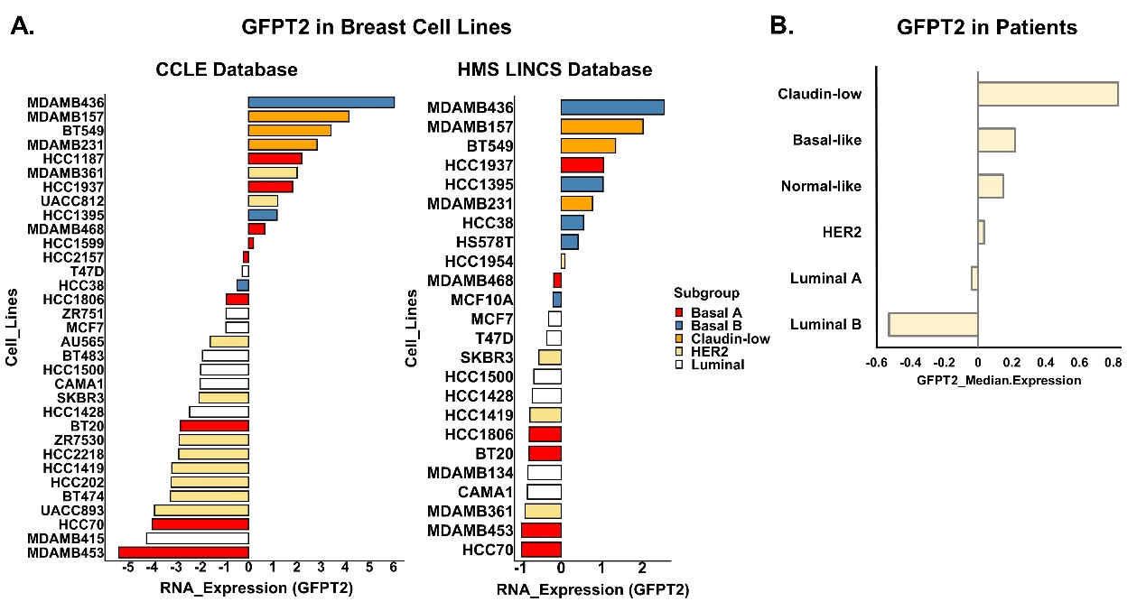

***Figure 10.* GFPT2 is higher in basal and claudin-low breast cell lines and same trend was shown in breast cancer patients. (A)** Based on data from an open source database – CCLE (<https://portals.broadinstitute.org/ccle>), GFPT2 was higher in basal and claudin-low cell lines while lowly expressed in HER2-positive and luminal cell lines. **(B)** Same trend was seen with data from another open source database – HMS LINCS (<http://lincs.hms.harvard.edu/db/datasets/20348/>). **(C)** TCGA data (Breast Cancer (METABRIC, Nature 2012 & Nat Commun 2016)) suggested GFPT2 was expressed highly in claudin-low patients while its expression was lower in HER2-positive and luminal patients.

***Data used:***

*"C:\Users\lenovo\OneDrive - Háskóli Íslands\PC-HI\5 ProteomicPaper\Figures&Tables in the paper\CCLE\mRNA expression (RNAseq)_ GFPT2.txt - CCLE*

*C:\Users\lenovo\OneDrive - Háskóli Íslands\PC-HI\5 ProteomicPaper\Figures&Tables in the paper\HMS_Dataset_20348\13058_2017_855_MOESM2_ESM_SE Smith2017_HMSdataset_final.xlsx - HMS*

*C:\Users\lenovo\OneDrive - Háskóli Íslands\PC-HI\5 ProteomicPaper\Figures&Tables in the paper\Figures\Figure 10\RawData\brca_metabric\data_clinical_patient.txt and data_expression_median.txt - Patients"*

***Note:***

*"CCLE: download GFPT2 data from CCLE website --> z-score and plotting in R*

*HMS: download data from HMS website --> organize in excel --> z-score and plotting in R*

*used Smith's paper to characterize the breast cell lines for both CCLE and HMS*

*Read ""README.txt"" in C:\Users\lenovo\OneDrive - Háskóli Íslands\PC-HI\5 ProteomicPaper\Figures&Tables in the paper\ProteomicsManuscript_03.07.2019\NewFigures&Data_2020\1-MainFigures\Fig.10*

*Patients: download data from TCGA --> Calculate in R --> plot in excel"*

***README.txt:***

*DPYD paper (with MMS signaures):*

*It doesn't have expression data for genes in each cell line*

*TNBC-iBAQ paper:*

*It doesn't have HER2 data, just TNBC and Luminal.*

*We can only use this for the dendrogram plotting because we can use the iBAQ data*

*So I combined HMS dataset with Smith's paper (cell line characterization) and CCLE dataset with Smith's paper:*

*HMS: less cell lines*

*CCLE: more cell lines*

*Smith's paper for classification*

*I can combine the TNBC-iBAQ and Smith's paper together for cell characterization, but they don't really agree with each other.*

*But i replaced the "Basal B" with "Mesenchymal" for three cell lines "BT549","MDAMB231", "MDAMB157"*

***Location:***

*"C:\Users\lenovo\OneDrive - Háskóli Íslands\PC-HI\5 ProteomicPaper\Figures&Tables in the paper\CCLE\Rfiles\CCLE-GFPT2-BreastCellType.R*

*C:\Users\lenovo\OneDrive - Háskóli Íslands\PC-HI\5 ProteomicPaper\Figures&Tables in the paper\HMS_Dataset_20348\HMS-BreastCancerType-GFPT2-Expression.R*

*C:\Users\lenovo\OneDrive - Háskóli Íslands\PC-HI\5 ProteomicPaper\Figures&Tables in the paper\Figures\Figure 10\Rfiles\Patients_BC_Type_GFPT2.R"*

1. **Tables in the main text**

***Table 1.*** **Summary of the LFQ and SILAC proteomic datasets.** Proteins were considered as valid identifications when at least two out of three replicates in one cell line were detected with at least one peptide. Protein signatures: a list of proteins up- or down-regulated in one cell type comparing to the other two cell types.

|  |  |  |  |  |  |
| --- | --- | --- | --- | --- | --- |
| 3,595 is without DEE (FDR < 1%, from the Dundee LFQ method section) | | **LFQ** | **SILAC**  All numbers are from supplementaryData1&2 | | |
| **Fractionation** | | single shot | 10 fractions | | |
| **Replicates (per cell line)** | | 3 | 3 | | |
| **Peptides identified** | | 28,766 | 67,118 (Replicate 1) | 70,314 (Replicate 2) | 68,645 (Replicate 3) |
| **Total protein groups** | | 3,595 | 7,166 (Replicate 1) | 7,390 (Replicate 2) | 7,317 (Replicate 3)  NewFigures&Data_2020\2-MainTables\Table1 |
| **Quantifiable protein detected in at least two out of three replicates**  (Proteins were considered as valid and used for later analysis) | | 2,705 | 5,120  Based on peptide columns of E, M, H | | |
| **Identifiable proteins in LFQ dataset** | | 3,546 | n.a | | |
| **D492 vs D492M**  (Unique proteins) | **Proteins only identified in D492** | 104 | n.a | | |
| **Proteins only identified in D492M** | 142 | n.a | | |
| **D492HER2 vs. D492**  (Unique proteins) | **Proteins only identified in D492HER2** | 129 | n.a | | |
| **Proteins only detected in D492** | 123 | n.a  Figures&Tables in the paper\Figures\Table1.R | | |
| **D492HER2 vs. D492M**  (Unique proteins) | **Proteins only identified in D492HER2** | 76 | n.a | | |
| **Proteins only identified in D492M** | 108 | n.a | | |
| **D492 vs. D492M vs. D492HER2**  (Unique proteins) | **Proteins only identified in D492** | 59 | n.a | | |
| **Proteins only identified in D492M** | 44 | n.a | | |
| **Proteins only identified in D492HER2**  Annotations\ProteinSignatureInCells\LFQ_SILAC_Protein Signatures in EHM_05.09.2019.R | 31 | n.a | | |
| **Protein signatures of all cell lines**  (Supplementary Data 3) | **D492 cell line signature** | 312 (210 downregulated and 102 upregulated) | | | |
| **D492M cell line signature** | 97 (49 downregulated and 48 upregulated)  SupplementaryData3 | | | |
| **D492HER2 cell line signature** | 84 (19 downregulated and 65 upregulated) | | | |

***Location****: C:\Users\lenovo\OneDrive - Háskóli Íslands\PC-HI\5 ProteomicPaper\Figures&Tables in the paper\Tables.xlsx (excel sheet 1)*

***Table 2.* Metabolic targets identified by comparing one cell type to another.** These targets were with significance (Permutation-based FDR less than 0.05). They were at least two-fold changes comparing D492HER2 to D492M, D492HER2 to D492 and D492M to D492. The fold changes were confirmed by LFQ and SILAC results. The average of Log2 ratios from LFQ and SILAC were reported in this table.

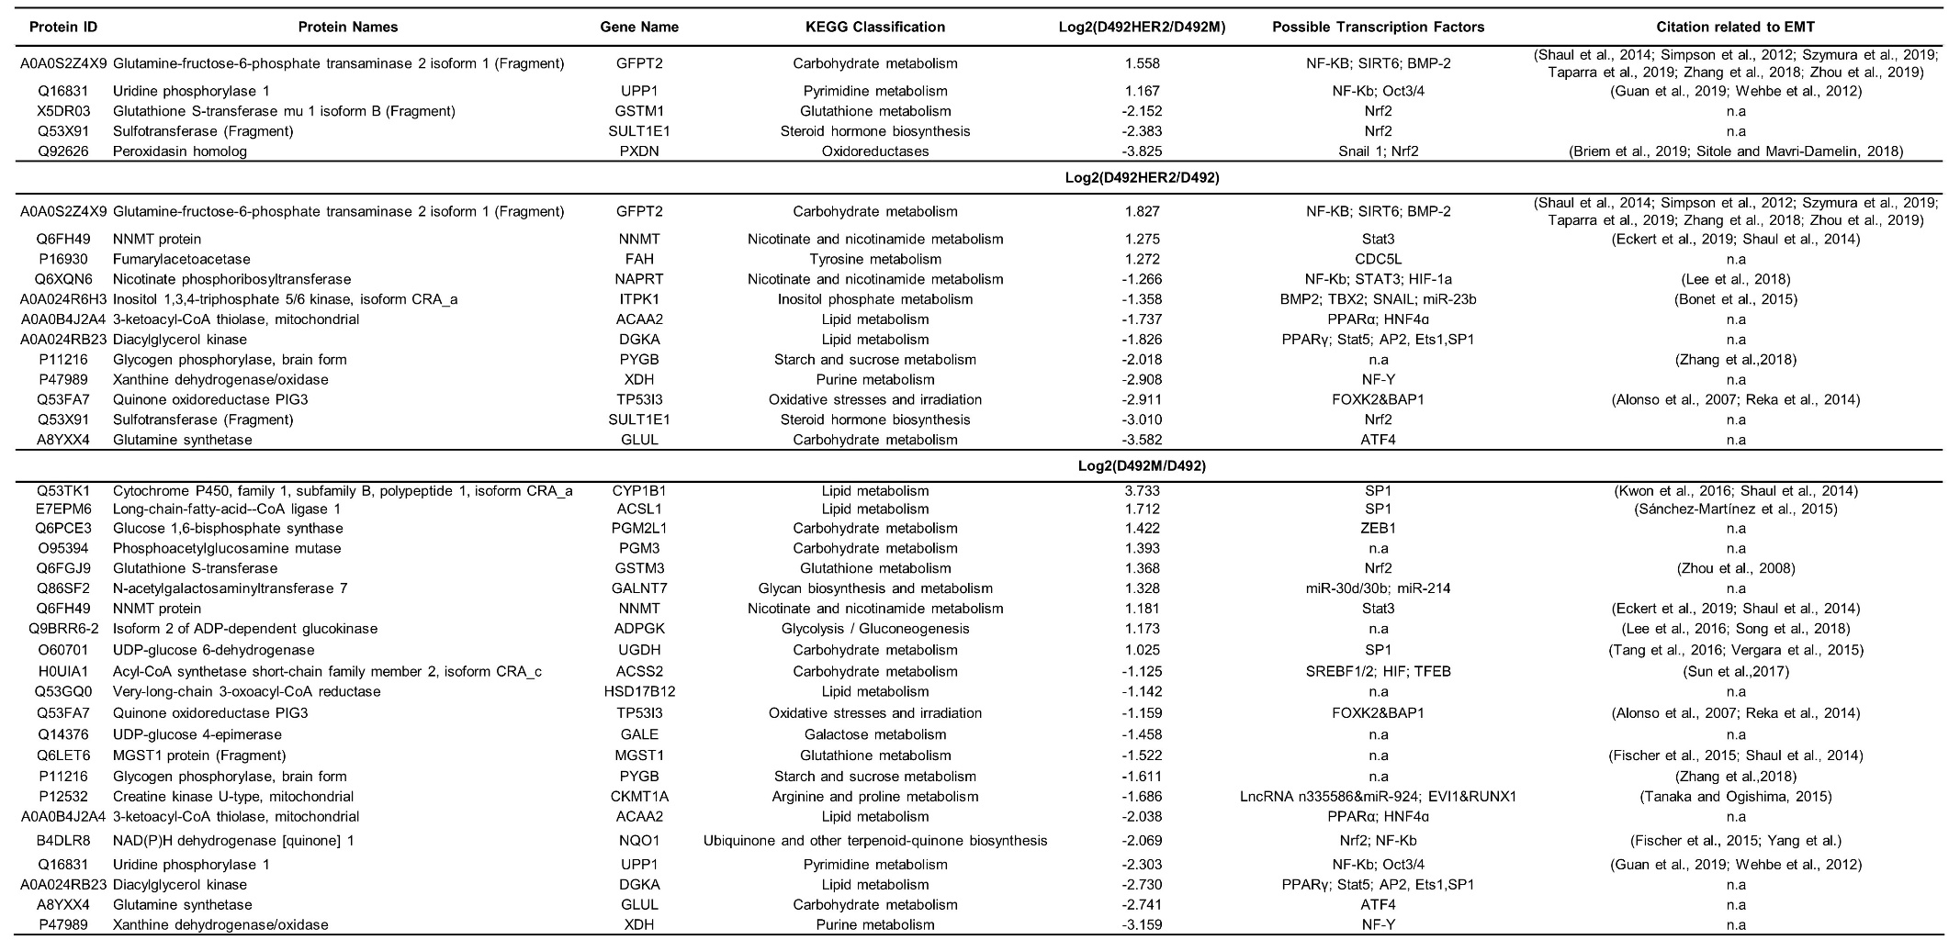

1. **Supplementary Figures**

**S.Fig. 1**

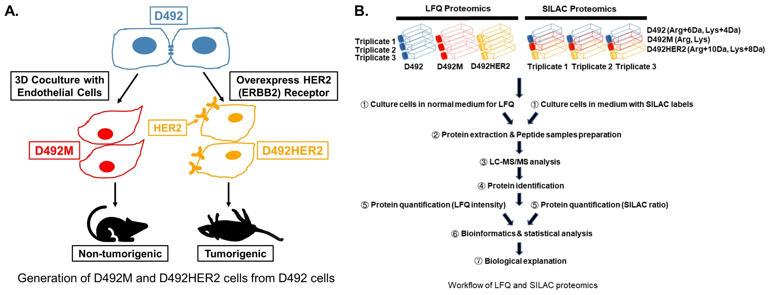

***Supplementary Figure 1*. Overview of the study**. **(A)** The process of generating D492M and D492HER2 from D492. Coculture D492 cells with endothelial cells (BRENCs or HUVECs) to generate spindle colonies and subculture the spindle colonies to generate a new cell line: D492M. D492M cells are non-tumorigenic; Overexpress HER2 (ERBB) receptor on D492 cells to generate D492HER2 cell line and these cells can form tumors in mice. **(B)** An overview of the whole experimental setup in this study from cell culture of D492, D492M and D492HER2 to bioinformatic and biological analysis of the LFQ and SILAC proteomic datasets.

***Location****: C:\Users\lenovo\OneDrive - Háskóli Íslands\PC-HI\5 ProteomicPaper\Figures&Tables in the paper\Figures\SupplementaryFig1*

**S.Fig.2**

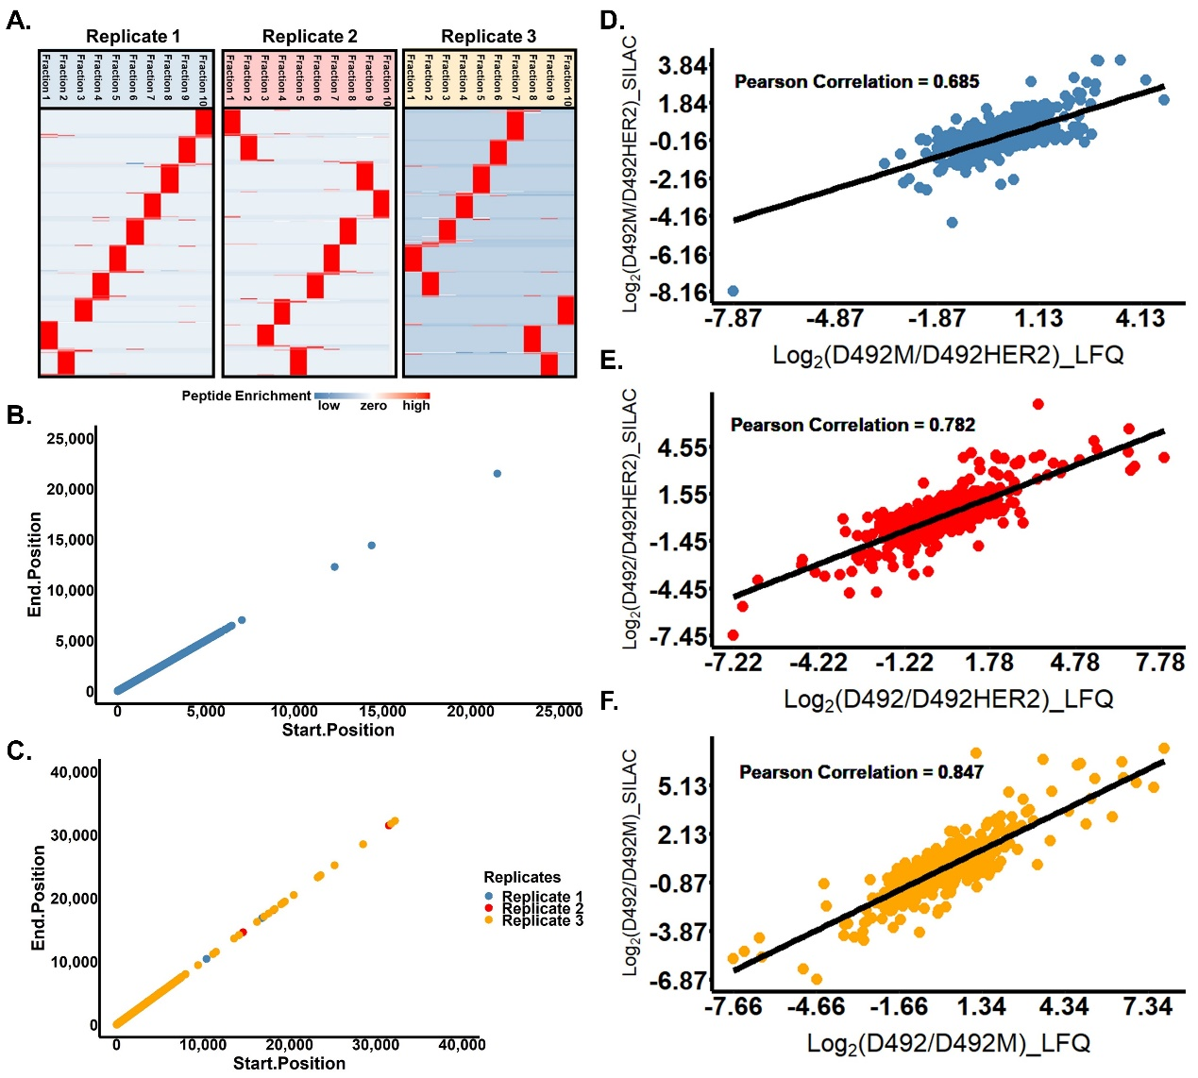

***Supplementary Figure 2*. LFQ vs. SILAC**. **(A)** Peptides were well fractionated into 10 fractions for the three replicates in the SILAC proteomic experiment. **(B)** SILAC experiment which covered 35,000 amino acids length had a bigger coverage than LFQ in which only 25,000 amino acid were covered for peptide detection **(C)**. **(D-F)** The consistency between LFQ and SILAC proteomic datasets regarding ratios of D492 and D492M **(D)**, D492 and D492HER2 **(E)** and D492M and D492HER2 **(F)**. Pearson comparison coefficient were listed. Identified and quantified proteins in both LFQ and SILAC datasets were used for comparison. Proteins needed to be detected in at least two out of three replicates in LFQ dataset while detected with at least two ratios in three SILAC replicates. Log2 ratios were plotted in the scatter plot with LFQ data on the x-axis and SILAC data on the y-axis.

***Location:***

*C:\Users\lenovo\OneDrive - Háskóli Íslands\PC-HI\2 SILIC_DundeePhosphoproteomicsDataset\Results\Peptide table\Peptide_05.09.2019.R*

*C:\Users\lenovo\OneDrive - Háskóli Íslands\PC-HI\5 ProteomicPaper\Figures&Tables in the paper\ScatterPlot\ScatterPlot_04.09.2019.R*

***Note:***

1. *Used the “Peptide” excel sheet from the raw data and produced in Perseus*
2. *Generated in Perseus and plotted in R*
3. *Genes identified and quantified in both LFQ and SILAC*
4. *at least 2 out of 3 replicates in LFQ*
5. *at least 2 out of 3 ratios in SILAC*
6. *Log2FC were plotted*
7. *no information about pvalue, so genes could be significant or not"*

*To generate the scatter plots*

*1. In Perseus&excel, find genes in both LFQ and SILAC, no matter for pvalues or directions because this is what you want to plot to see the correlation so you cannot select data manually*

*2. mean of LFQ and median of SILAC for the triplicates*

*3. import into R for plotting the scatter plot*

*4. marked the >=1 or <=-1 (deleted in the end)*

*5. labeled the top 50 genes (deleted in the end)*

**S.Fig.3**

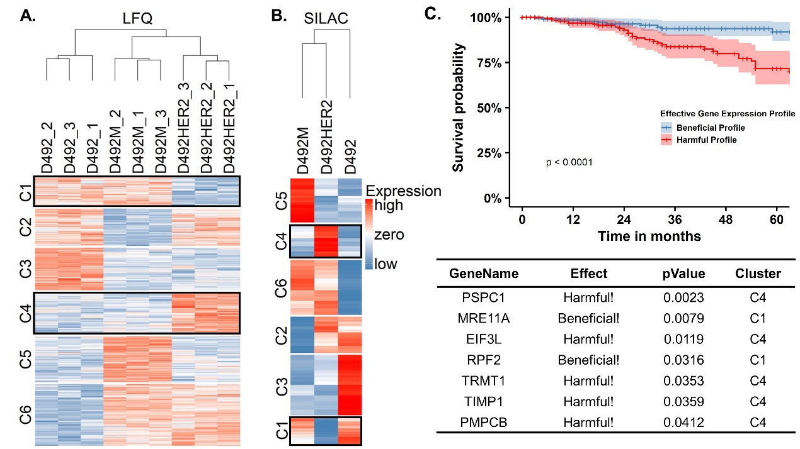

***Supplementary Figure 3*. “Signature proteome” among D492, D492M and D492HER2.** Proteomic data based on both LFQ **(A)** and SILAC **(B)** have clustered D492M and D492HER2 together. ‘Signature proteins’ for D492 (C3 and C6), D492M (C2 and C5) and D492HER2 (C1 and C4) were defined as protein groups differentiating different cell types. Protein clusters (C1 and C4) were outlined as “Signature Proteins” in D492HER2. Heatmap of LFQ proteome was plotted using proteins with significant differences (LFQ, ANOVA, and Permutation-based FDR < 0.05) while heatmap of SILAC proteome was plotted using SILAC data (Coefficient of Variation of SILAC ratios < 0.1). **(C)** Survival analysis of D492HER2 cells’ signature proteins on breast cancer patients of all types revealed a group of proteins (listed in the table) which might affect patients’ overall survival. The effect of each protein on patients together with the p value for each enzyme’s effect and the cluster in which each enzyme was resided were listed. TCGA data, Breast Invasive Carcinoma (TCGA, Provisional), was used in this analysis.

***Location:***

*C:\Users\lenovo\OneDrive - Háskóli Íslands\PC-HI\5 ProteomicPaper\Figures&Tables in the paper\Annotations\ProteinSignatureInCells*

*C:\Users\lenovo\OneDrive - Háskóli Íslands\PC-HI\5 ProteomicPaper\Figures&Tables in the paper\SurvivalCurveGeneration_17.09.2019*

***Note:*** *Heatmap: Median for SILAC not mean (you can check on the Perseus file “Annotations for E M HER2_SILAC_1.6.2.2.sps” in the folder “ProteinSignatureInCells”)*

*LFQ: 1841 proteins for plotting*

*SILAC: 2838 proteins for plotting*

*Survival analysis: All 1066 patients + HER2 signature protein from supplementary data 6*

*Then, selected 7 proteins, did the analysis again with all 1066 patients and all types of breast cancer*

**S.Fig.4**

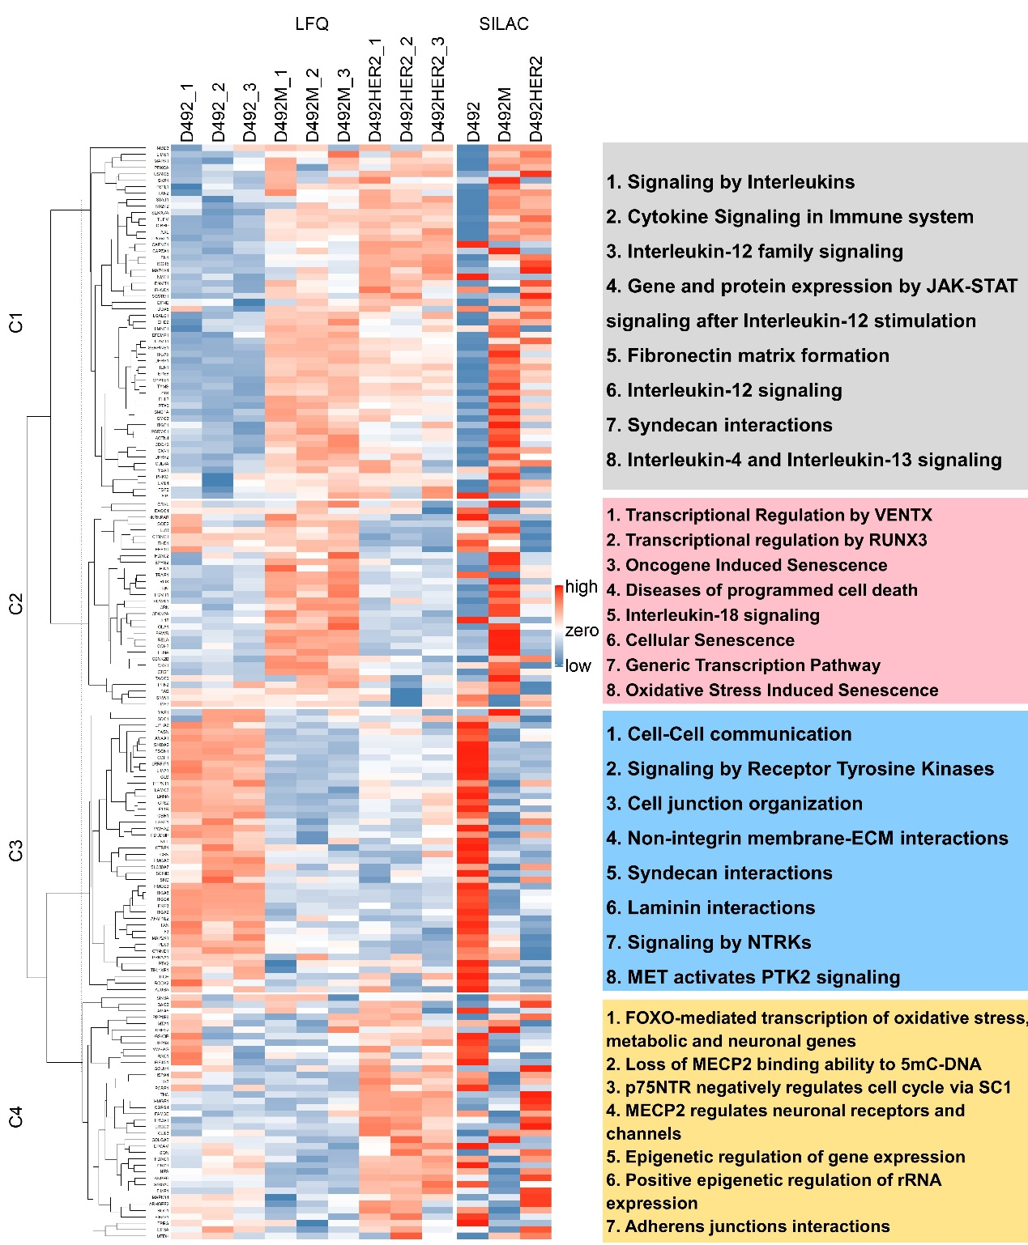

***Supplementary Figure 4*. EMT markers from database: dbEMT2**. To comprehensively present the expression levels of EMT markers in different cell types, we plotted all EMT markers detected in this study based on an open EMT database (dbEMT2: <http://dbemt.bioinfo-minzhao.org/>). EMT markers detected in the study were clustered into four groups. Pathways were enriched for each cluster based on the Reactome pathway database (Version 72) and top pathways in each group (FDR < 0.01) were listed on the right side. The proteins in each cluster were listed in Supplementary Data 5 with relative information.

***Location:***

*C:\Users\lenovo\OneDrive - Háskóli Íslands\PC-HI\5 ProteomicPaper\Figures&Tables in the paper\dbEMT*

*dbmet2.txt*

*dbEMT2.R*

*Figures are in the folder “Figures”*

*C:\Users\lenovo\OneDrive - Háskóli Íslands\PC-HI\5 ProteomicPaper\Figures&Tables in the paper\dbEMT\OutputData\dbEMT2_LFQ_SILAC_GN-in-Each-Cluster-2020.04.18.xlsx*

*C:\Users\lenovo\OneDrive - Háskóli Íslands\PC-HI\5 ProteomicPaper\Figures&Tables in the paper\dbEMT\Reactome-dbEMT2*

*Note: comparing to the figure 1A, there are only 12 out of the 26 genes in figure 1A are in this figure.*

**S.Fig.5**

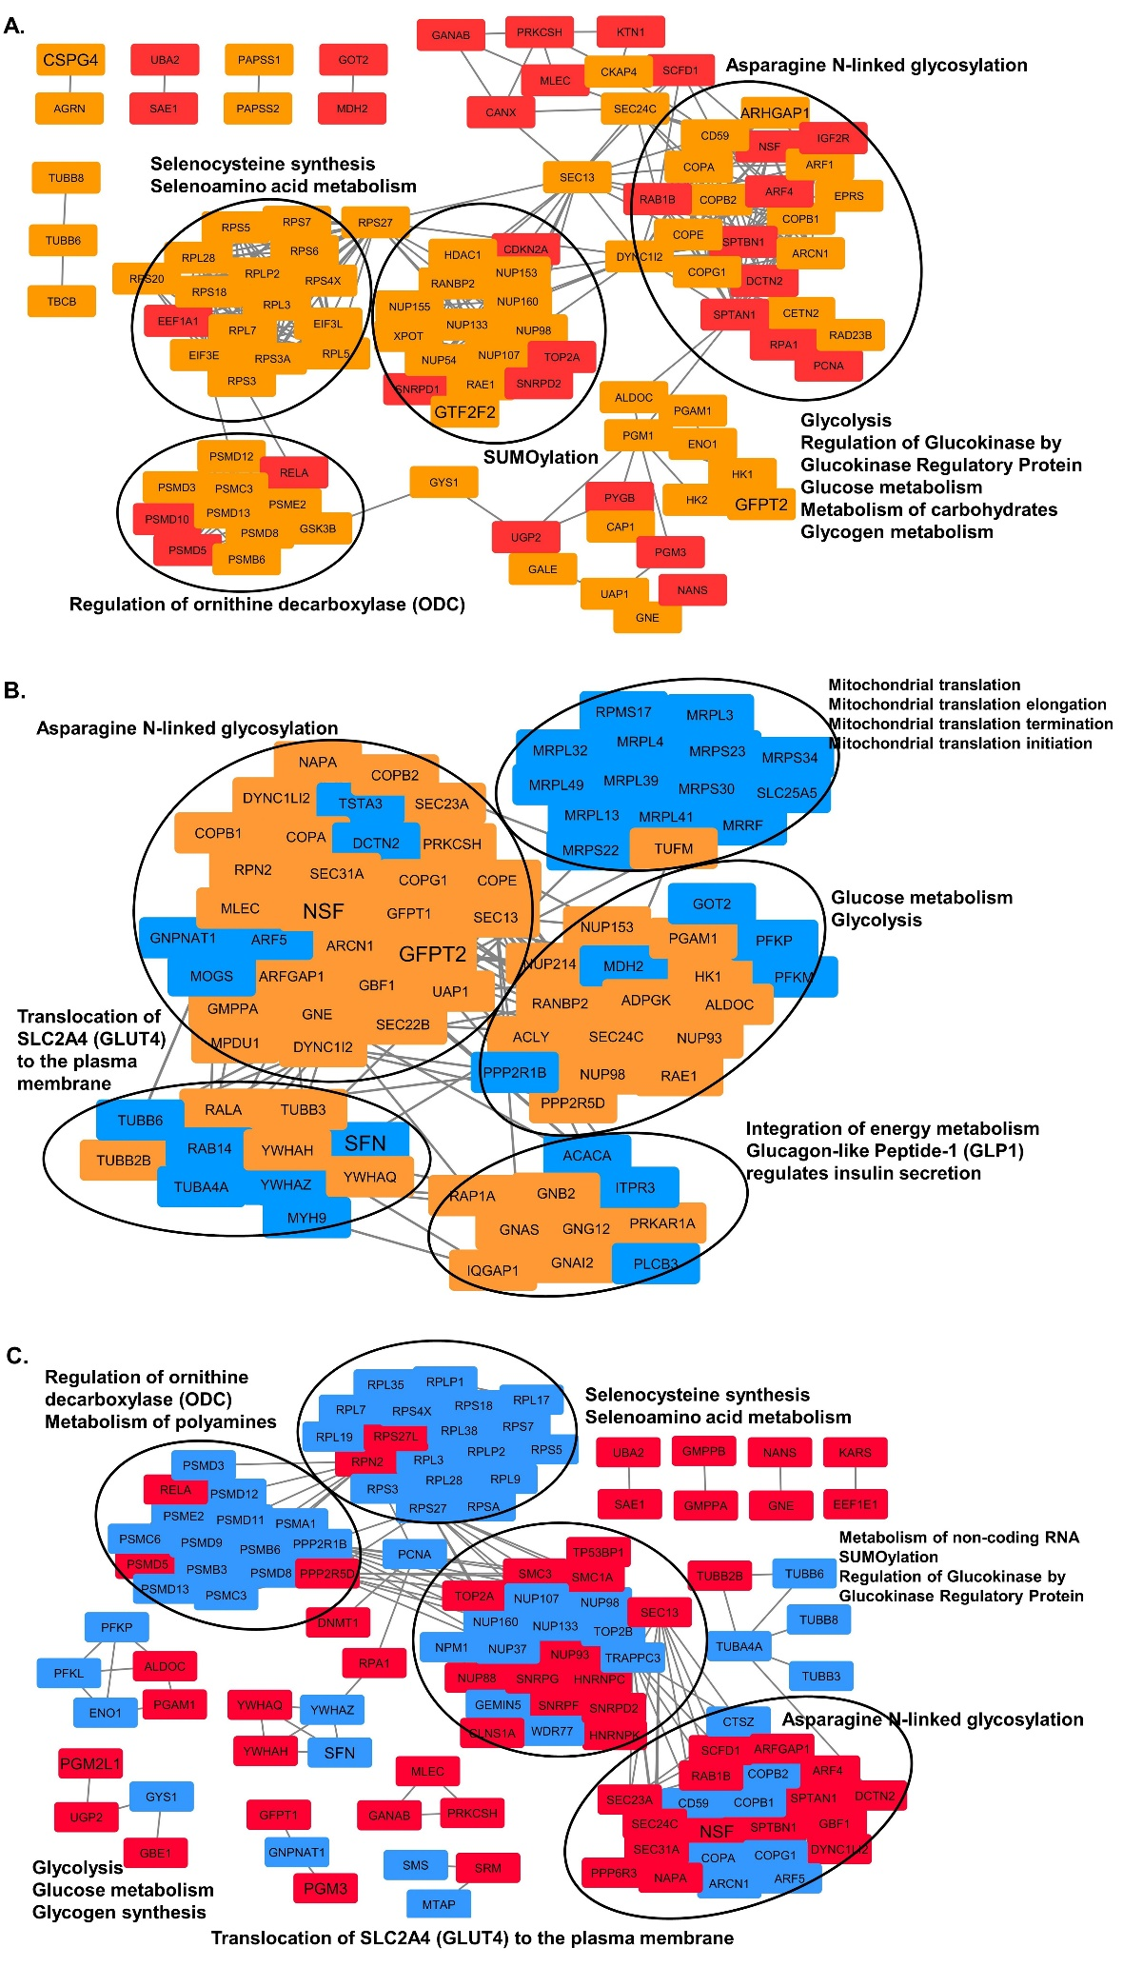

***Supplementary Figure 5.* Interaction network of changed proteome in metabolism.** **(A)** Reactome metabolic pathways differently enriched in D492HER2 vs. D492M and proteins involved. Proteins marked in orange were up-regulated in D492HER2, protein marked in red were up-regulated in D492M. **(B)** Reactome metabolic pathways differently enriched in D492HER2 vs. D492 and proteins involved. Proteins marked in orange were up-regulated in D492HER2, protein marked in blue were up-regulated in D492. **(C)** Reactome metabolic pathways differently enriched in D492M vs. D492 and proteins involved. Proteins marked in red were up-regulated in D492M, protein marked in blue were up-regulated in D492. Gene names with enlarged labels were proteins with at least 2-fold differences between two cell types. Proteins involved in enriched metabolic pathways (FDR < 0.05) were connected and clustered in STRING (Version 11.0; k-means clustering, minimum required interaction scores: medium confidence 0.400) and visualized in Cytoscape (version 3.5.1/Version 3.6.1). Pathways were enriched with all differentially expressed proteins (Supplementary Data 6) between cell types by Reactome Pathway Enrichment Analysis (Version 65, 67 and 72).

***Data used:***

*"C:\Users\lenovo\OneDrive - Háskóli Íslands\PC-HI\5 ProteomicPaper\Figures&Tables in the paper\IPA\ImportFile*

*Proteomics_LFQ&SILAC_X.xlsx"*

***How the figure was generated:***

*"1. Reactome pathways*

*2. Metabolic Reactome Pathways*

*3. Genes in metabolic pathways*

*4. STRING interaction*

*5. Cytoscape*

*6. Color up- or down-regulated genes*

*7. Enlarge genes with at least 2-fold differences"*

***Location:***

*"C:\Users\CSB\OneDrive - Háskóli Íslands\PC-HI\5 ProteomicPaper\Figures&Tables in the paper\Annotations\Reactome\Metabolic Proteins_E vs M*

*C:\Users\CSB\OneDrive - Háskóli Íslands\PC-HI\5 ProteomicPaper\Figures&Tables in the paper\Annotations\Reactome\Metabolic Proteins_H vs E*

*C:\Users\lenovo\OneDrive - Háskóli Íslands\PC-HI\5 ProteomicPaper\Figures&Tables in the paper\Annotations\Reactome\Metabolic Proteins_H vs M"*

"C:\Users\lenovo\OneDrive - Háskóli Íslands\PC-HI\5 ProteomicPaper\Figures&Tables in the paper\Annotations\Reactome

C:\Users\CSB\OneDrive - Háskóli Íslands\PC-HI\5 ProteomicPaper\Figures&Tables in the paper\Annotations\Reactome\Metabolic Proteins_E vs M\EM

C:\Users\CSB\OneDrive - Háskóli Íslands\PC-HI\5 ProteomicPaper\Figures&Tables in the paper\Annotations\Reactome\Metabolic Proteins_H vs E\HE

C:\Users\lenovo\OneDrive - Háskóli Íslands\PC-HI\5 ProteomicPaper\Figures&Tables in the paper\Annotations\Reactome\Metabolic Proteins_H vs M\STRING-output"

**S.Fig.6**

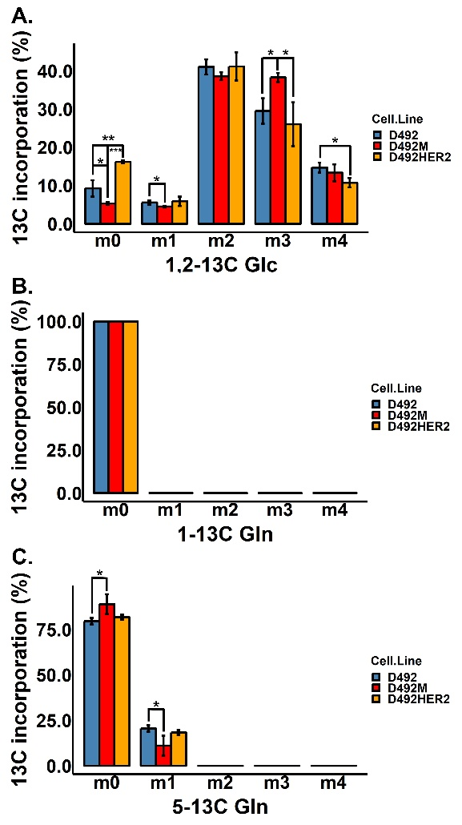

***Supplementary Figure 6.* Percentage of 13C incorporation after 6 hours’ cell culture with 1,2-13C Glc (A), 1-13C Gln (B) and 5-13C Gln (C) in all cell types. (A)** UDP-GlcNAc molecules were most with two 13C labels, followed by three 13C labels in all cell types when culturing with 1,2-13C Glc. The percentage of carbons with no 13C incorporation from 1,2-13C Glc in D492HER2 was higher than D492. D492M had the least percentage of carbons without labels. The percentage of carbons with three labels 1,2-13C Glc was the highest in D492M. **(B)** No 13C incorporation from 1-13C Gln in all cell types. **(C)** UDP-GlcNAc molecules were most with no 13C label in all cell types when culturing with 5-13C Gln. The percentage of carbons with no label from 5-13C Gln was higher in D492M than in D492 while D492M had significantly lower percentage of carbons with one label from 5-13C Gln as compared to D492. **\***: p < 0.05; **\*\***: p < 0.01; **\*\*\***: p < 0.001.

***Data used:***

*C:\Users\lenovo\OneDrive - Háskóli Íslands\PC-HI\5 ProteomicPaper\Figures&Tables in the paper\Metabolomics_Arnar_Labelling_April2019\ARNAR_Targeted_UDP_NaGlu_isotopologues_All_Cell_Lines.xlsx*

***Location:***

*C:\Users\lenovo\OneDrive - Háskóli Íslands\PC-HI\5 ProteomicPaper\Figures&Tables in the paper\Metabolomics_Arnar_Labelling_April2019\Rfiles\Labelling_Arnar_EMH_m_TP_NotStack_29.08.2019.R*

*C:\Users\lenovo\OneDrive - Háskóli Íslands\PC-HI\5 ProteomicPaper\Figures&Tables in the paper\Metabolomics_Arnar_Labelling_April2019\Figures*

**S.Fig.7**

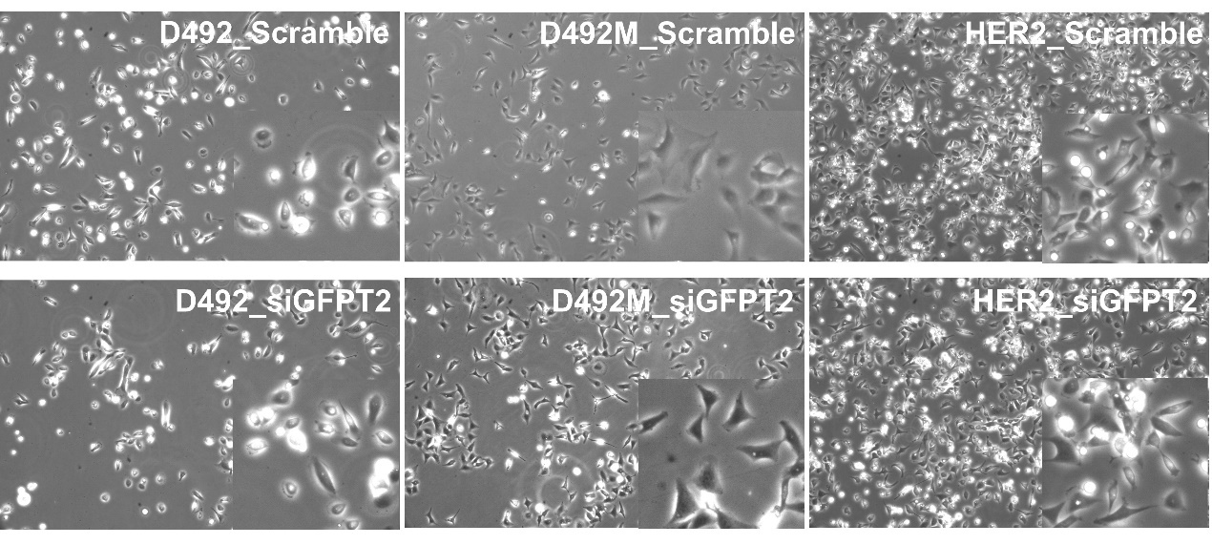

***Supplementary Figure 7.* Phenotype of D492, D492M and D492HER2 after knockdown of GFPT2.** Cell phenotype was not noticeably changed in all cell types after knocking down of GFPT2.

***Location:***

*C:\Users\lenovo\OneDrive - Háskóli Íslands\PC-HI\4 Experiments documents_QIONG\14 Knockdowns Experiments\Results\11 KD_Phenotype*

***Note:***

*Find the original photos of cells in the portable harddrive*

**S.Fig.8**

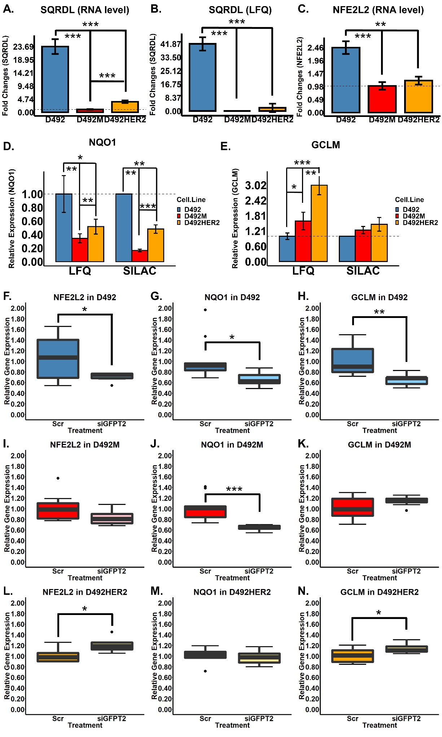

***Supplementary Figure 8.* Influence of GFPT2 on RNA expression of NFE2L2 and genes controlled by the Antioxidant Response Element (ARE) – NQO1 and GCLM. (A-B)** SQRDL was overexpressed in D492 at both RNA **(A)** and protein level **(B)**. **(C)** NFE2L1 overexpressed at RNA level in D492. **(D)** NQO1 was highly expressed in D492 while expressed at the lowest level in D492M. This was confirmed by both LFQ and SILAC.

**(E)** Based on LFQ, GCLM was highly expressed in D492HER2 while expressed at the lowest level in D492. **(F-H)** NFE2L2 **(F)**, NQO1 **(G)** and GCLM **(H)** were downregulated after knockdown of GFPT2 in D492. **(I-K)** NQO1 **(J)** was downregulated with knockdown of GFPT2 in D492M. **(L-N)** NFE2L2 **(L)** and GCLM **(N)** were upregulated when knocking down GFPT2 in D492HER2. **\***: p < 0.05; **\*\***: p < 0.01; **\*\*\***: p < 0.001.

***Data used:***

*"C:\Users\lenovo\OneDrive - Háskóli Íslands\PC-HI\5 ProteomicPaper\Figures&Tables in the paper\Figures\SupplementaryFig6\ProteomicPaperTargets_RNAexpression.xlsx - SQRDL_RNA and Nrf2_RNA - organized data - SQRDL_RNA & Nrf2_RNA*

*C:\Users\lenovo\OneDrive - Háskóli Íslands\PC-HI\4 Experiments documents_QIONG\14 Knockdowns Experiments\Results\14 SQRDL\WideType\RTqPCR_WT_EMH_SQRDL_04.02.2020.xlsx & RTqPCR_WT_EMH_NRF2_PA_21.02.2020.xlsx - Original data - SQRDL_RNA & Nrf2_RNA*

*C:\Users\lenovo\OneDrive - Háskóli Íslands\PC-HI\5 ProteomicPaper\Figures&Tables in the paper\Figures\SupplementaryFig6\ProteomicPaperTargets.xlsx - SQRDL_LFQ*

*C:\Users\lenovo\OneDrive - Háskóli Íslands\PC-HI\4 Experiments documents_QIONG\14 Knockdowns Experiments\Results\14 SQRDL\Knockdown - original data*

*C:\Users\lenovo\OneDrive - Háskóli Íslands\PC-HI\4 Experiments documents_QIONG\14 Knockdowns Experiments\Results\15 KDefficiency_siRNA1&2\RNA_GeneExpression.xlsx - organized data"*

***Location:***

*C:\Users\lenovo\OneDrive - Háskóli Íslands\PC-HI\4 Experiments documents_QIONG\14 Knockdowns Experiments\Results\15 KDefficiency_siRNA1&2\Rfiles\BoxPlot_Function_OneGene_2020.02.24.R*

*"C:\Users\lenovo\OneDrive - Háskóli Íslands\PC-HI\5 ProteomicPaper\Figures&Tables in the paper\Figures\SupplementaryFig6\Figures_ROSgenes*

*C:\Users\lenovo\OneDrive - Háskóli Íslands\PC-HI\4 Experiments documents_QIONG\14 Knockdowns Experiments\Results\14 SQRDL\Figures"*

***Note:***

*SQRDL_LFQ, generated by using the same R code, just morfidied a bit: C:\Users\lenovo\OneDrive - Háskóli Íslands\PC-HI\5 ProteomicPaper\Figures&Tables in the paper\Figures\SupplementaryFig6\Rfiles\GNexpression_RNA_RTqPCR_04.09.2019.R*

1. **Supplementary table**

Table.S1: Primers used in this study

1. **Supplementary data**

**SD1: SupplementaryData1_ProteomicDataLFQ.xlsx**

4 excel sheets:

1. README
2. LFQ rawdata from Dundee
3. Protein_Groups data from Dundee (it is the same as LFQ rawdata with extra rows and columns for the contamination protein etc. and with all the information for each protein group)
4. Peptides data

***Location:***

*Z:\Projects\EMT\QIONG\Proteo&Phosphoproteo_QIONG_2017-2018\Proteomics_LFQ_summary_16.04.2018*

*C:\Users\lenovo\OneDrive - Háskóli Íslands\PC-HI\1 DundeeProteomicDataSet_14112017\iBAQ__LFQ&LFQ rawdata*

**SD2: SupplementaryData2_ProteomicDataSILAC.xlsx**

10 excel sheets:

1. README
2. Organized D492/D492M ratios
3. Organized D492HER2/D492M ratios
4. Organized D492HER2/D492 ratios
5. Proteins_R1 with all details for the SILAC proteomic run (Replicate 1)
6. Proteins_R2 with all details for the SILAC proteomic run (Replicate 2)
7. Proteins_R3 with all details for the SILAC proteomic run (Replicate 3)
8. Peptides_R1 with peptides information for Replicate 1
9. Peptides_R2 with peptides information for Replicate 2
10. Peptides_R3 with peptides information for Replicate 3

***Location:***

*Z:\Projects\EMT\QIONG\Proteo&Phosphoproteo_QIONG_2017-2018\Proteomics_SILAC_summary_score_28.12.2018*

*C:\Users\lenovo\OneDrive - Háskóli Íslands\PC-HI\2 SILIC_DundeePhosphoproteomicsDataset\Results\Proteomics\Analysis Results - OR_QIONG_RawData*

***Note****: deleted all the columns for Phosphoproteomic part*

**SD3: SupplementaryData3_SignatureProteins.xlsx**

3 excel sheets

Related to Table 1 in the main text

1. Protein signature of D492HER2
2. Protein signature of D492M
3. Protein signature of D492

***Location:***

*C:\Users\lenovo\OneDrive - Háskóli Íslands\PC-HI\5 ProteomicPaper\Figures&Tables in the paper\Annotations\ProteinSignatureInCells*

*C:\Users\lenovo\OneDrive - Háskóli Íslands\PC-HI\5 ProteomicPaper\Figures&Tables in the paper\Annotations\ProteinSignatureInCells\ LFQ_SILAC_Protein Signatures in EHM_05.09.2019.R*

***Note****: based on the heatmap from Perseus, manually selected the signature proteins, then used R to automatically select the signature proteins based on the output from Perseus.*

Since at the beginning, I used CV to cut off the SILAC data, then I tried to find the p values or FDR for the protein signature, but I didn’t use the p value data and just reported as “down-regulated” or “up-regulated”. Details should be found in the R file.

*How the data were generated*

*1. import the 10,178 proteins of D492/D492M and D492HER2/D492M, set D492M to 1 in Perseus (Annotations for E M HER2_SILAC_1.6.2.2.sps)*

*2. export from Perseus*

*3. import SILAC (CV < 0.1) and LFQ (AVONA FDR < 0.05) data into Perseus to get heatmap*

*4. check Perseus file for details (C:\Users\CSB\OneDrive - Háskóli Íslands\PC-HI\5 ProteomicPaper\Figures&Tables in the paper\Annotations\ProteinSignatureInCells\LFQ_ProteinSignatureInCells\Annotations for E M HER2_LFQ_1.6.2.2.sps) (Annotations for E M HER2_SILAC_1.6.2.2.sps)*

*5. get heatmap 6 clusters*

*6. export the clusters*

*7. export separately for More in E, Less In E, More in M, Less in M, More in HER2 and Less in HER2*

*8. find proteins with the same directions (Check in Excel and R)*

**SD4: SupplementaryData4_EMTmarkers.xlsx**

One Excel sheet:

Summarize the EMT markers in the literature: Meta-analysis of gene expression signature defining the Epithelial to Mesenchymal Transition during cancer progression

***Location:***

*C:\Users\lenovo\OneDrive - Háskóli Íslands\PC-HI\5 ProteomicPaper\Figures&Tables in the paper\ProteomicsManuscript_03.07.2019\NewFigures&Data_2020\5-SupplementaryData*

**SD5: SupplementaryData5_EMTmarkers_dbEMT2_Clusters-in-Heatmap.xlsx**

Four excel sheets:

This dataset is correlated with S.Fig.4 dbEMT2 markers

Cluster_1: information about the genes in C1 in the heatmap

Cluster_2: information about the genes in C2 in the heatmap

Cluster_3: information about the genes in C3 in the heatmap

Cluster_4: information about the genes in C4 in the heatmap

***Data used:***

*C:\Users\lenovo\OneDrive - Háskóli Íslands\PC-HI\5 ProteomicPaper\Figures&Tables in the paper\dbEMT\dbemt2.txt &*

*C:\Users\lenovo\OneDrive - Háskóli Íslands\PC-HI\5 ProteomicPaper\Figures&Tables in the paper\dbEMT\OutputData\dbEMT2_LFQ_SILAC_GN-in-Each-Cluster-2020.04.18.xlsx*

***Note:***

*"1. generate gene list ""dbEMT2_LFQ_SILAC_GN-in-Each-Cluster-2020.04.18.xlsx"" in R*

*2. in R, found all the genes and separated into clusters"*

***Location:***

*C:\Users\lenovo\OneDrive - Háskóli Íslands\PC-HI\5 ProteomicPaper\Figures&Tables in the paper\dbEMT\Rfiles\dbEMT2_LFQ_SILAC_GN-in-Each-Cluster-2020.04.18.R (generate gene list with the order in the heatmap) & dbEMT2_LFQ_SILAC_GN-in-Each-Cluster-details-2020.04.18.R (extract information based on the dataset downloaded from dbEMT2)*

**SD6: SupplementaryData6_DifferentlyExpressedProteins.xlsx**

Three excel sheets

D492HER2 vs. D492M: proteins are significantly different between D492HER2 and D492M (both LFQ and SILAC) and LFQ and SILAC have the same direction for changes

D492HER2 vs. D492: proteins are significantly different between D492HER2 and D492 (both LFQ and SILAC) and LFQ and SILAC have the same direction for changes

D492M vs. D492: proteins are significantly different between D492M and D492 (both LFQ and SILAC) and LFQ and SILAC have the same direction for changes

***Location:***

*"C:\Users\lenovo\OneDrive - Háskóli Íslands\PC-HI\5 ProteomicPaper\Figures&Tables in the paper\MatchingLFQ&SILAC\7 SILAC_LFQ_Diff_mean_median_23.11.2018 – original data*

*C:\Users\lenovo\OneDrive - Háskóli Íslands\PC-HI\5 ProteomicPaper\Figures&Tables in the paper\MatchingLFQ&SILAC\IPA.R & 2 Add-LFQ-FDR.R - important*

*C:\Users\lenovo\OneDrive - Háskóli Íslands\PC-HI\5 ProteomicPaper\Figures&Tables in the paper\ProteomicsManuscript_03.07.2019\NewFigures&Data_2020\5-SupplementaryData\SupplementaryData5_DifferentlyExpressedProteins – for HM*

*C:\Users\lenovo\OneDrive - Háskóli Íslands\PC-HI\5 ProteomicPaper\Figures&Tables in the paper\IPA\ImportFile – the files which were are in there*

*C:\Users\CSB\OneDrive - Háskóli Íslands\PC-HI\5 ProteomicPaper\Figures&Tables in the paper\Annotations\pathfindR\GOannotation\EM&HE&HM_03022019 – these data were also used for GO annotation*

***Note:***

*1. LFQ and SILAC data (rawdata)*

*2. significant statistics (used Perseus for imputation and significance test)*

*3. proteins in both LFQ and SILAC*

*4. FDR of LFQ and p value of SILAC are both below 0.05 (a bit over for HE, like 0.0503)*

*5. same directions (up- or down- regulated)*

*6. for EM, HE and HM*

*7. reported the mean of Mean_LFQ and Median_SILAC*

*NOTE: only plotting the GO annotation in pathfindR for EM and HE*

*Note: for Perseus and IPA, didn’t delete the proteins with SILAC p value >0.05*

**SD7:** **SupplementaryData7_KEGGPathwayEnrichment.xlsx**

Three excel sheets:

1. KEGG pathway enrichment in pathfinder: D492HER2 vs. D492M
2. KEGG pathway enrichment in pathfinder: D492HER2 vs. D492
3. KEGG pathway enrichment in pathfinder: D492M vs. D492

***Location:***

*C:\Users\lenovo\OneDrive - Háskóli Íslands\PC-HI\5 ProteomicPaper\Figures&Tables in the paper\Annotations\pathfindR\BubbleChart_2020.04.07*

***Note:***

*This excel file is coordinated with figure 4 in the main text*

*Referred to the R file to plot:*

*C:\Users\lenovo\OneDrive - Háskóli Íslands\PC-HI\5 ProteomicPaper\Figures&Tables in the paper\Annotations\pathfindR\Rfiles\ GOannotation_&enrichment_EM&HE&HM_2020.01.08.R*